QGIS Workshop March 16th 2015

QGIS Workshop – Making a two variable comparison map
There are three files we will be working with – a Michigan county shape file, a cell phone tower shape file and a csv spreadsheet. They can be found here: http://archive.lib.msu.edu/maps/Workshops/UP_QGIS_Mar2016/
We will be making an additional file based on the County Shapefile and joining the spreadsheets to the shape file and the newly created file to create a choropleth map and a graduated symbol to overlay on that map.
- Add the shapefile by clicking the vector + button on the top left of the layer window (circled below).
Browse to the shapefile location, click on it (this is the file with the .shp extension, the other files are associated with the .shp but are not the one to open) and open it, then click open again in the add vector layer box.
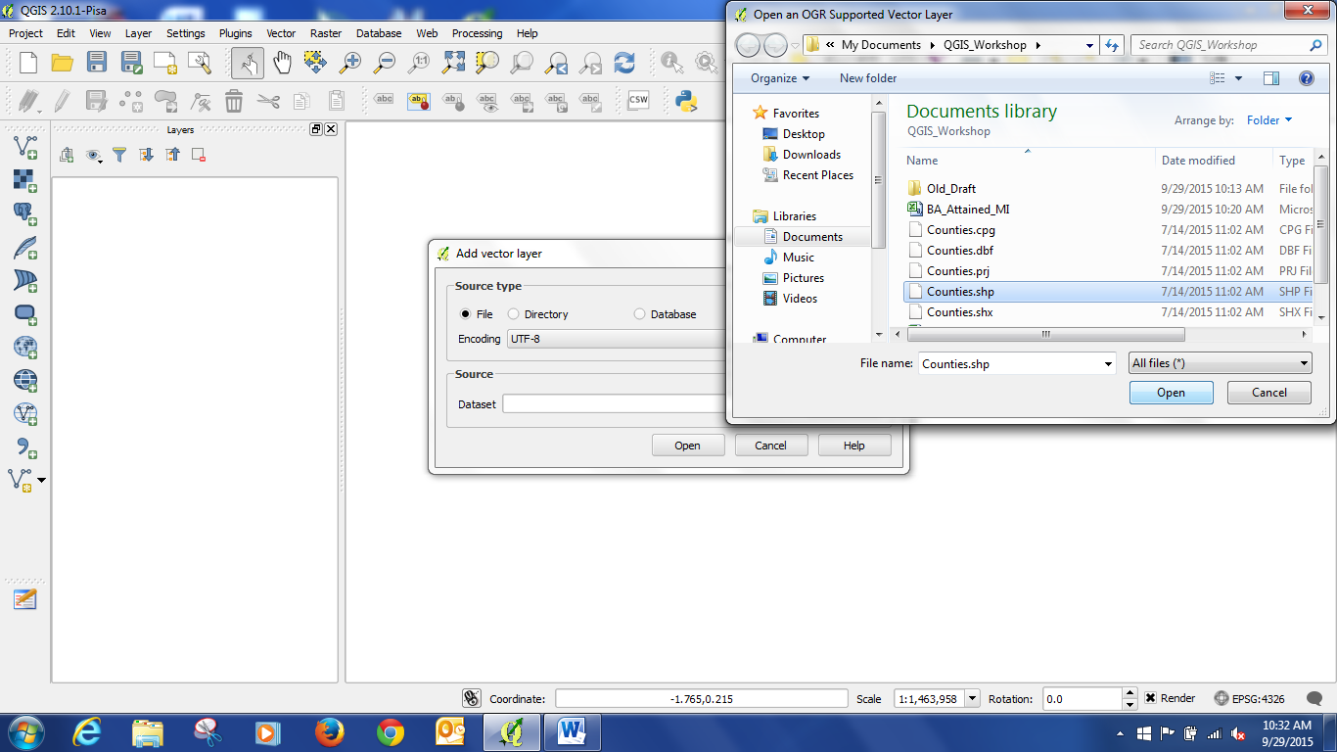
Now you should have the file opened and it should look like this:
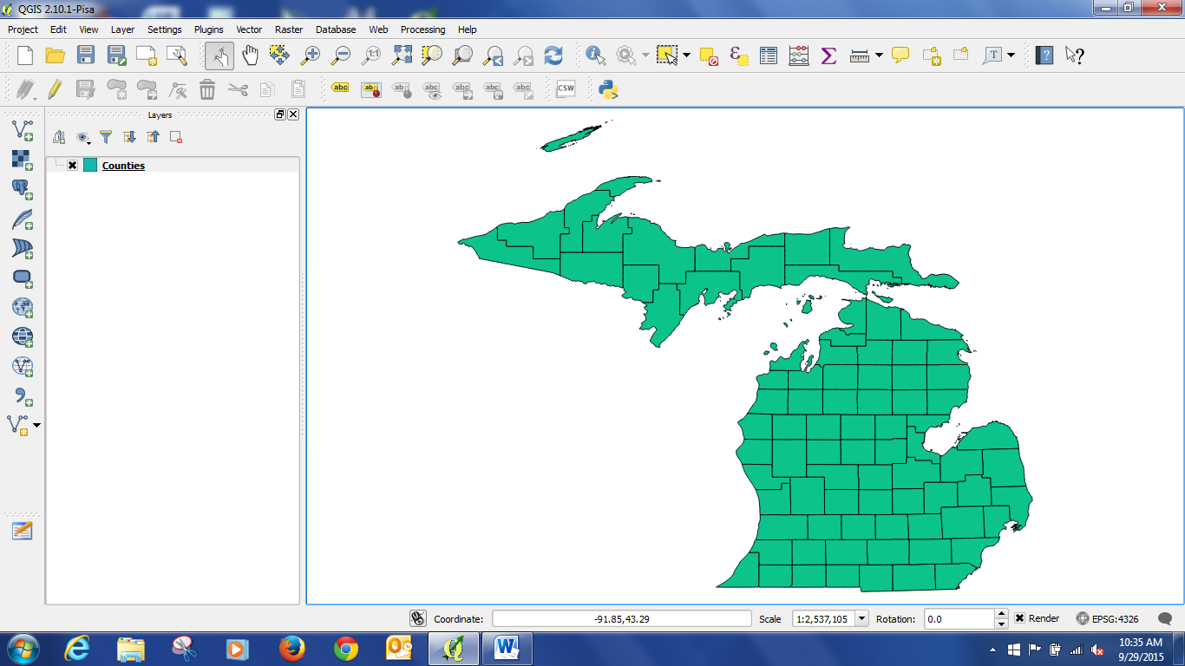
Let’s quickly review some information about this file… right click on Counties in the Layers list, and then click on Properties.
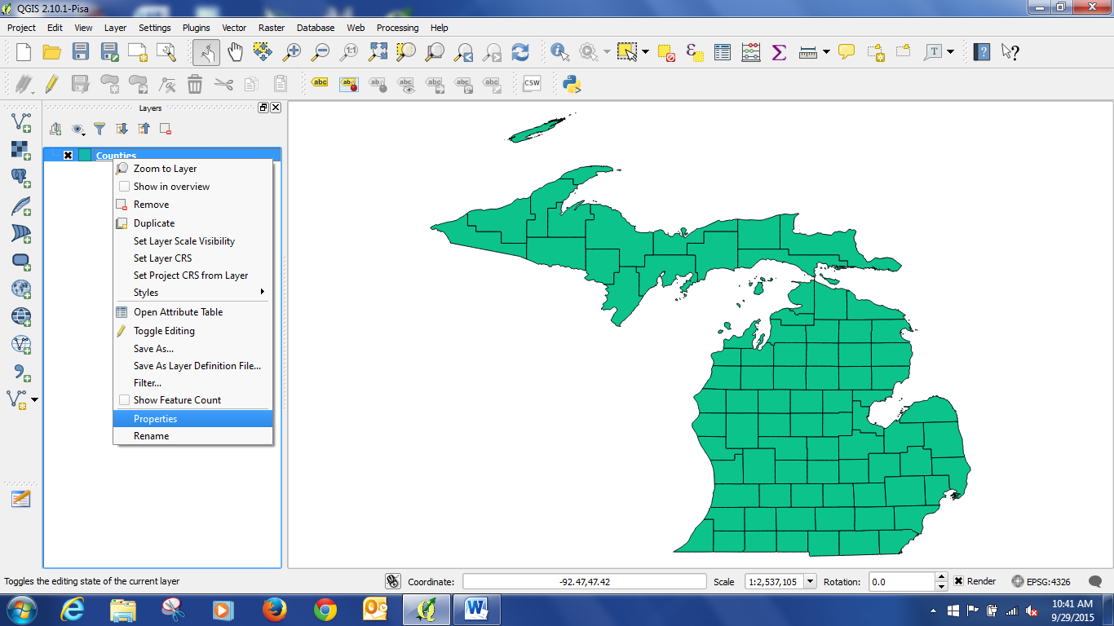
Then click on General.
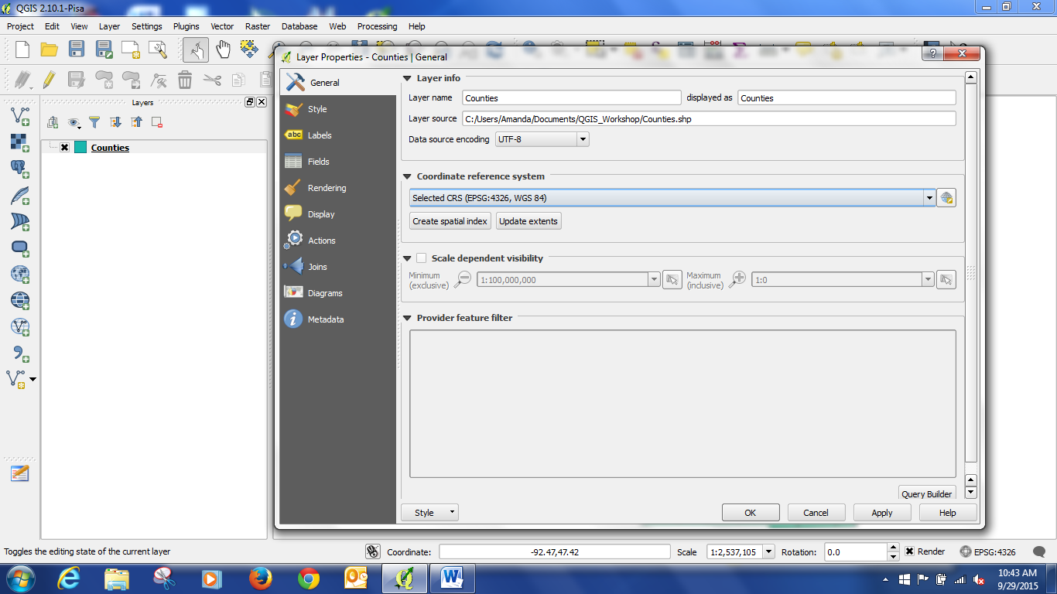
We can see that the coordinate system is WGS 84. This is a typical default coordinate system. It is what was defined by the source of the shapefile, the GIS Open Data Website of the State of Michigan. It is a good practice to review your shapefiles and make sure that you are using an appropriate and matching coordinate system for all your layers.
- Now we will make a centroid layer based on the shapefile. Close the layer properties window. Then click on the Vector menu -> Geometry Tools -> Polygon centroids.
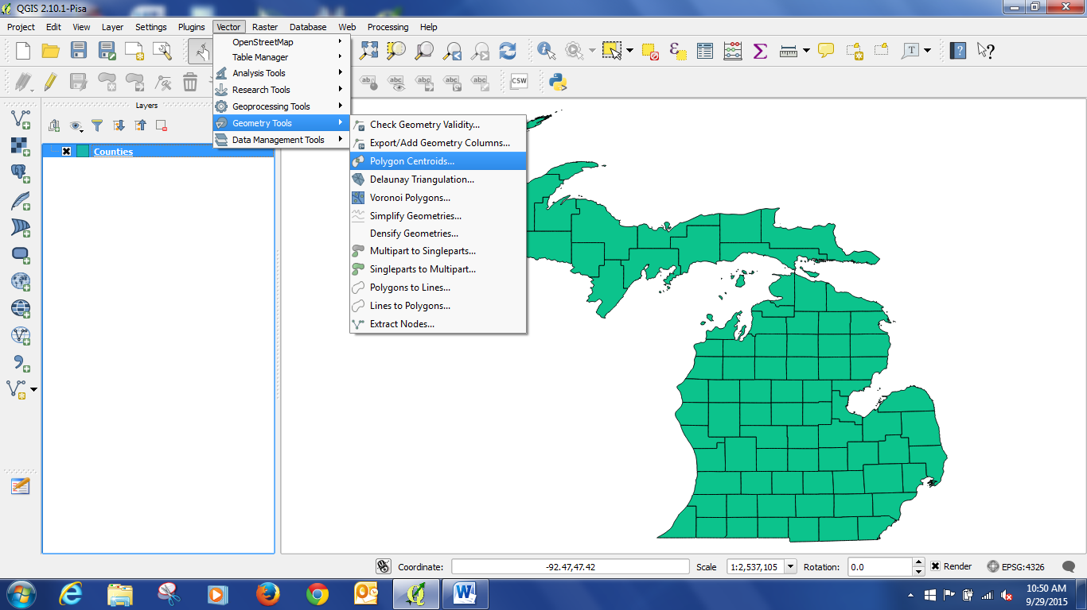
Click browse to select a place to save the new file, and give it a name, “CountyCentroids” Click save in the Save output shapefile window. Then click “Okay.” Now you should have a centroid layer, and your project should look something like this: 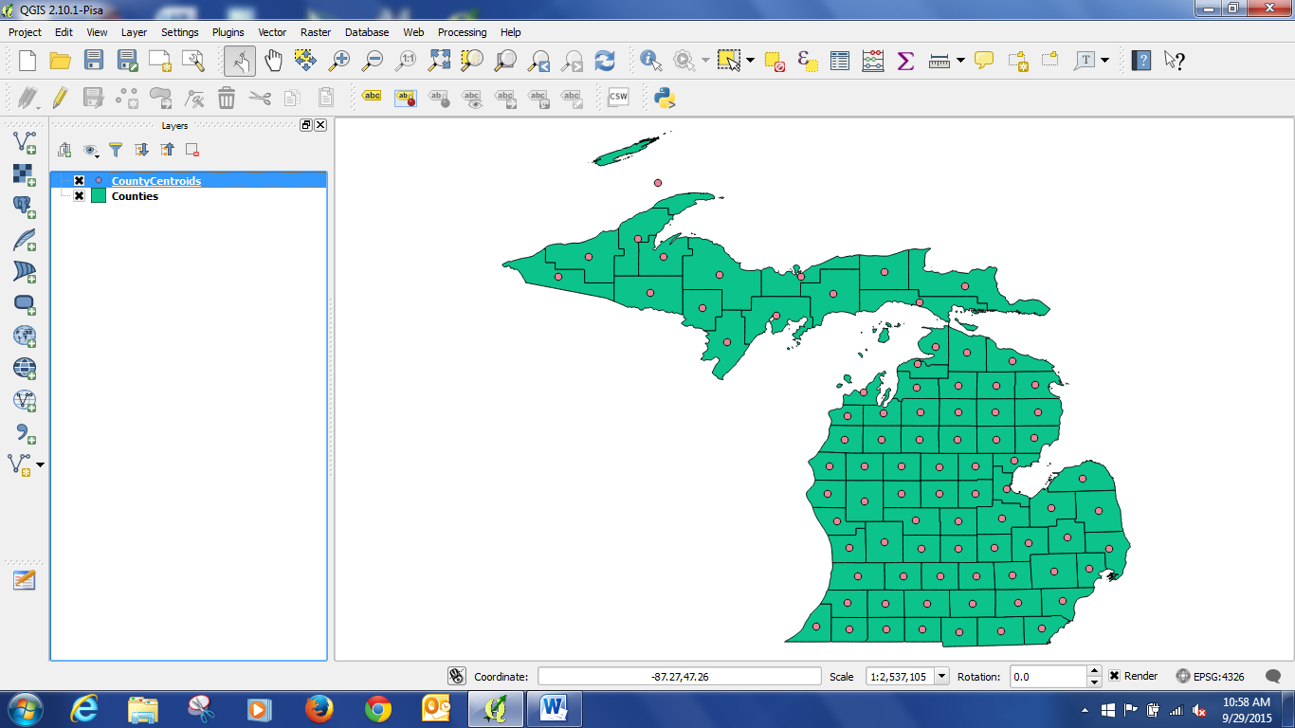
Now would be a good time to save your project. Saving a project does not save changes to individual files, but will save the links to them. Click the Project menus, select save and save your project in the same space as the centroid shapefile. (no screen shot for this)
- Editing the centroid file. Notice that one of the polygons was split – Mackinaw Island caused the centroid to appear in the middle of the lake. This will not look good for comparison with the other centroids, so we should move it.
Select the CountyCentroids layer by clicking on it.
Then click on the Edit Toggle Button (circled in red).
Then click on the Move Features Button.
Then click on the errant point and move it off the lake onto the county (see arrow).
Once you have it where you want it, click the Save Edits button and toggle Editing off by clicking the Edit Toggle button.
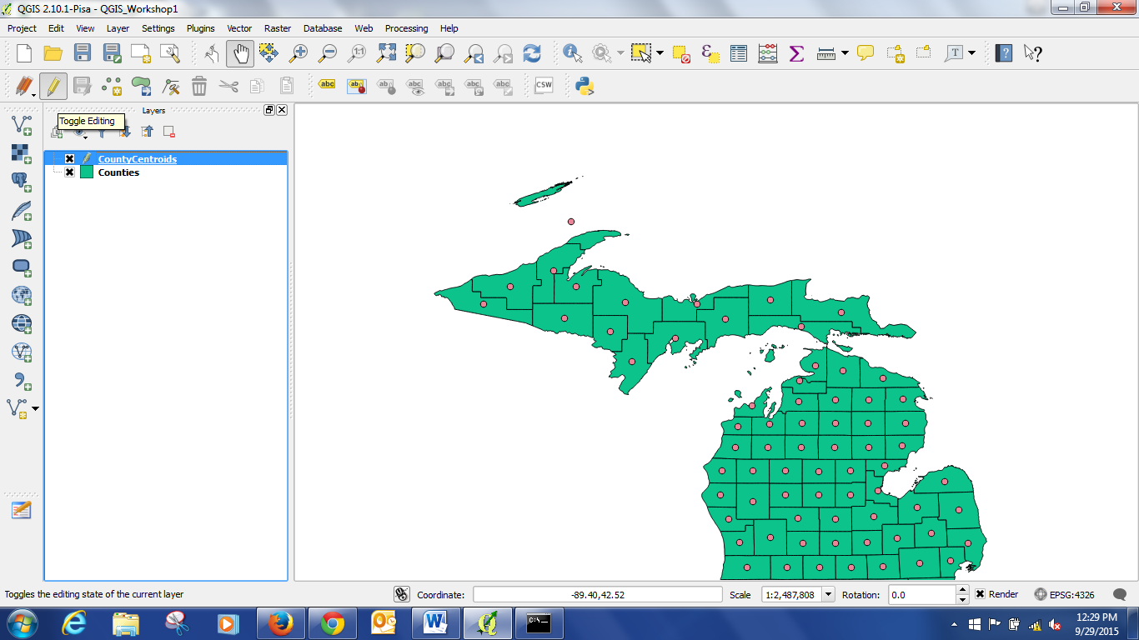
- Now that we have the base layers in place, we need to connect them to some data. We will be comparing median income and percentage of people with bachelor’s degrees. So let’s open the .csv files with that information.
You can do this if you have an excel file by clicking on the add vector data button that we used to add the shapefile. However, I have found that QGIS preserves file headers and format better as csv files. So to add a csv file, click the apostrophe icon at the bottom left of the layers box. Then Browse to the BA_Attained_MI csv file and click Open. Under Geometry definition: click No Geometry (circled).

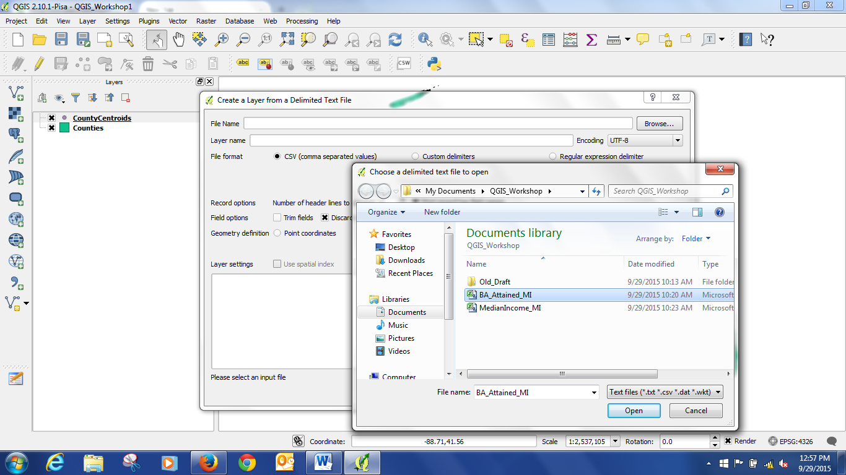
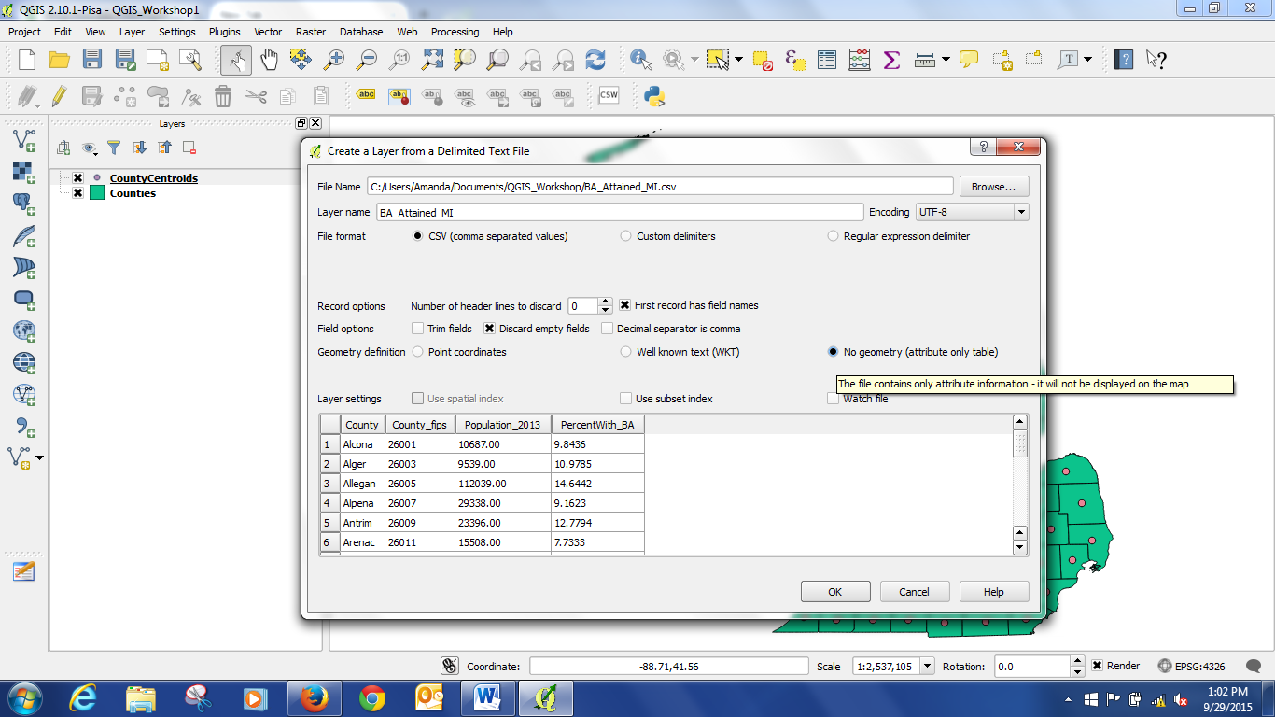

We should check that the table fields are in the format we need them to be in. Right click on the MedianIncome_MI layer and click on properties. Then go to the Fields section. The fields should have “double” for the Median income, and “string” for the County name. Double = number with decimal, string = text. Do the same check for the BA_Attained_MI table, “string” for County, “double” for PercentWith_BA. See below for a screen shot.

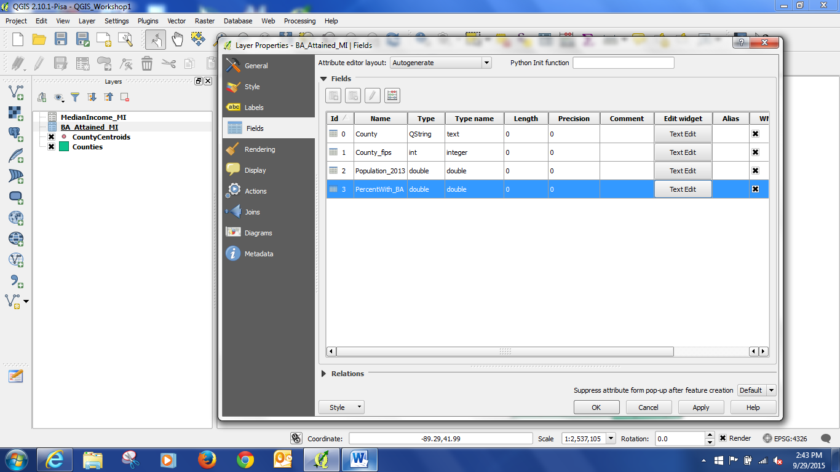

Now that the data is in the project, we can Join the tables to the shapefiles. Joining is a way of connecting shapefiles to data – but you need a common field between the two files to perform the join on. FIPS codes (from the census) are often used for this, but in this case we will just use the county name, from the “County” field in both tables. NOTE: To join tables – you must have perfectly matching fields of the same format (attribute type – string, double, etc.). If you do not, the tables will not join completely and you will have places without data due to the mismatch.

- To join the files: Right click on CountyCentroids and open the Properties box. Click on the Join icon. Then click on the plus icon at the bottom of the box (circled). This will bring up the Add Vector Join box. Make sure BA_Attained_MI is in the Join layer box. Then select County as the Join field, and County as the target field. Click the check box next to choose which fields are joined. This option lets you reduce redundant fields in your join. Then click Custom Name Prefix. Delete the file name, this will prevent QGIS from replacing your headers with the file name instead of something useful. Now if we go to the Fields tab in properties, the two joined fields should show up.

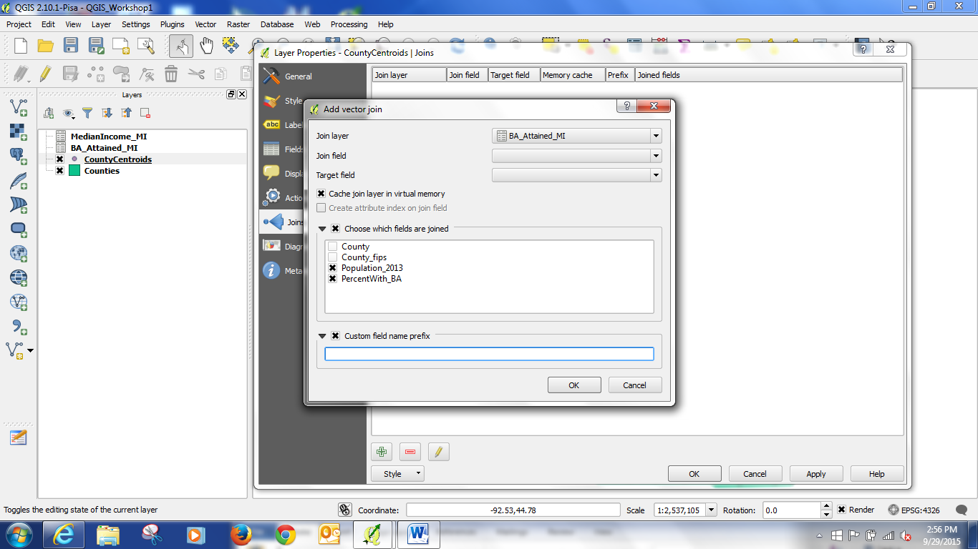

- Now the data is joined. In order to make the join permanent we need to save the layers via “Save As.” Right click on the CountyCentroids, and click on Save As. Then pick a name for the new file – CountyCentroidsJoined. Do the same thing for the Counties file.
- Now the shapefiles with the data to be compared are saved. The old files can now be removed. Right click on the tables and original shape files and click “Remove.” Tell it okay when it asks you if you want to remove the file from the project. NOTE: This does not delete the files. This simply removes them from the project.
- At this point we now have the files we need to make our map visualization. Right click on CountyCentroidsJoined, select Properties, and click on Style. At the top of the box, it will say “Single Symbol.” We want Graduated, so change that. Then under Column, select PercentWit (this is how QGIS messes up your headers by cutting them off, if there is time later I can show you how to fix that). Under Method, select Size. Choose the number of classes as 5. Hit classify. (There are different classification methods which are called modes, we will use the default – Equal Interval) Don’t worry if some look like boxes, that is just the edges of the circles being cut off. Hit Classify to make sure it is using your settings. If you want to change the color, hit the box next to symbol and adjust that. If the size of the symbols is too large, you can reduce the second value of size from. Then hit okay.
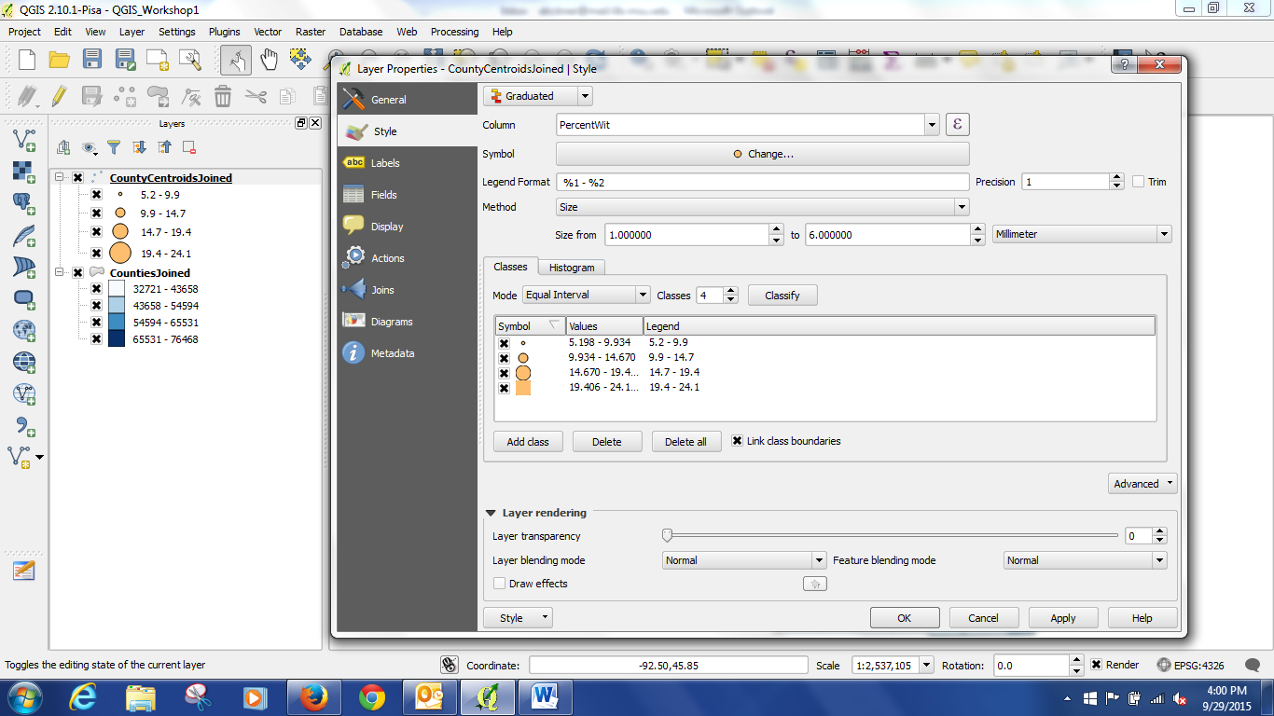
- To make the choropleth, we will follow a similar process. Right click on the CountiesJoined, select Properties, and click on Style. At the top of the box, again change to Graduated. Column = Median_Inc. Method = Color. Mode = Equal Interval. Classes = 5. Hit Classify. If you want to change the color, you can pick a different color ramp under Color ramp. Then hit Okay.
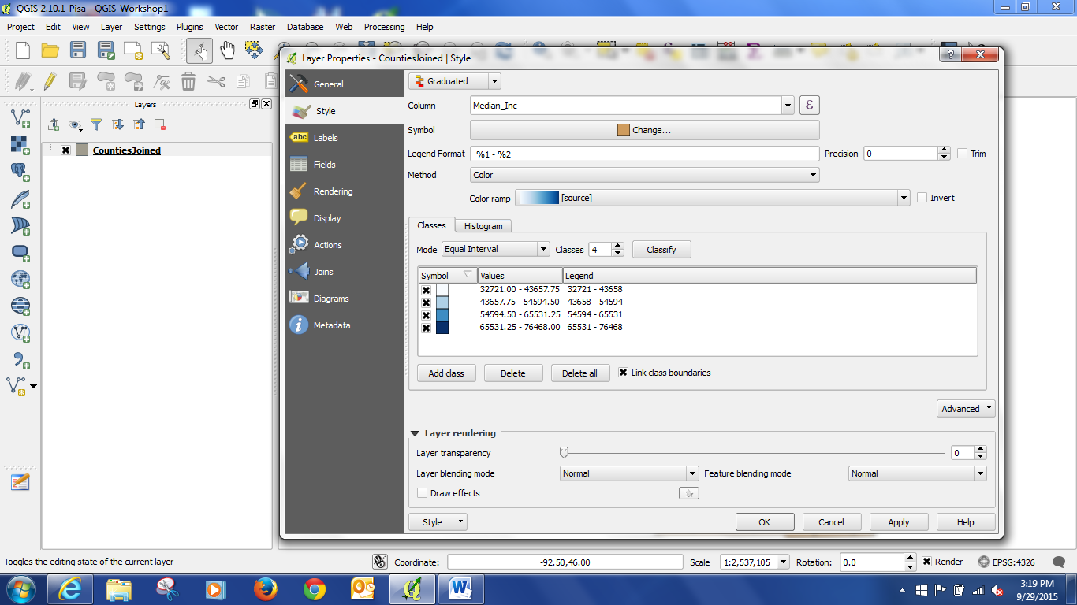
And voila, we have our map.
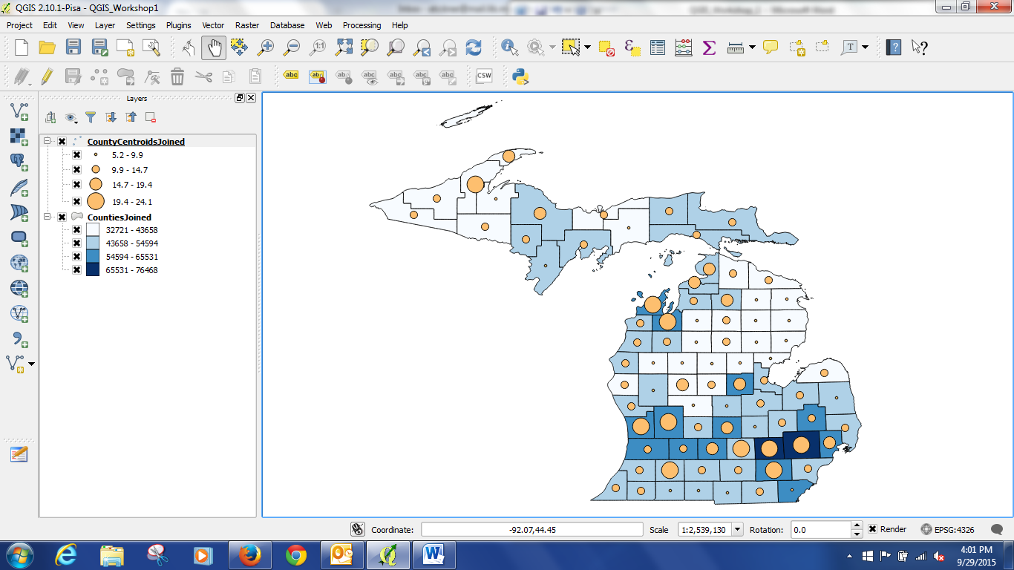
To export your map in a format you can include in a word document, you can go to Project in the menu, and select Save As an Image.
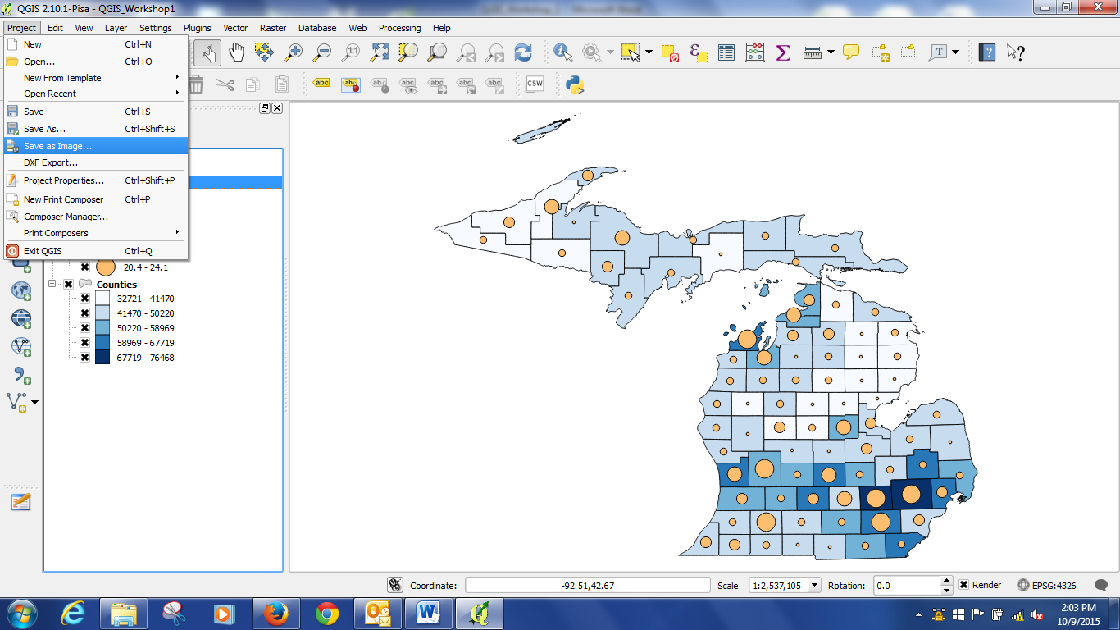
QGIS Workshop Part 2 (with thanks to Kathleen Weissess):

1) Adding Files and Turning off layers

The only new file we need to add is the cell phone tower file, you can add it using the add vector file button. You can turn the point file we made off by unchecking the check box next to it, or by right clicking and removing it.

2) Selecting by Attribute

Another useful thing we can do with the attribute table is select certain items in the map. Open the attribute table. Click and drag over the left most part of the table to select a number of records. On the map they appear as yellow.

We can unselect items very easily by clicking on the unselect button.

We can also use the select tool and select by geography. Draw a box over some of the points and the attribute table will highlight those items that are selected.

3) Extracting Features

We are now going to change some of the shapefiles. Sometimes a shapefile has too much information in it, and you wish that some of it were invisible or gone altogether.
An example here is the layer of cell phone towers. If we right click on the layer and choose zoom to extent, we are reminded that this file shows all of the United States. We can select just the Michigan cell phone towers and save them out as a separate shapefile.
You can select features by highlighting rows in the attribute table and drawing a box to select features. Both of those methods would work here. There are two other ways of selecting the items we want.
First we will use the county boundaries layer to carve out the cell phone towers. Sometimes this is called a “cookie cutter” function.
Highlight cell phone towers, then click on Vector, Research Tools, and Select by Location. Our input is the file cellular, and the intersect feature is Michigan Counties. This selects all the cell phone towers in Michigan.
Now right click on the cellular layer, open the attribute table to verify that the correct items were selected. Close the table, then choose Save As. Check the box to save only the selected features, and give the new layer a name.
The new layer is added to the project. You can now deselect the Michigan towers or even right click on the cellular layer and remove it from the project. This method is most useful when your attribute table doesn’t have the state information. This would also be useful when you area of interest is an irregular area for which you have a handy cookie cutter shapefile to use.
In the vector tools there is also under geoprocessing tools something called Clip. This will accomplish the same thing – using a shapefile to select from another shapefile.
Another way to select features is to select by query. We have a button at the top to create a query, and we could also open the attribute table and see the same button.
We can use anything we see in the attribute table as our search criteria. If it was important to our project, we could look at this column that has the structure type. We could select only towers that are a mast style. For this project I will instead query for towers that have MI in the state column.
Now that the items are highlighted, we can save them as a new layer and add them to the project.
It is time to save our project again so we don’t lose our work.
4) Adding a Buffer
In this segment we will draw a buffer around the cell phone towers. A buffer is the equivalent of drawing a circle around a feature. For instance, if we thought that the average range of a cell phone tower was about 10 miles, we could draw 10 mile buffers around each cell phone tower and see how much of the state is covered.
Select the cell towers layer and click on Vector – Geoprocessing Tools and Buffer.
Our input is cell phone towers and we specify a new name for the shapefile we are about to create.
Now is the tricky part. Shapefiles, depending on the coordinate system and projection they were created, are made up of a unit of measure. It could be feet, meters, or other. This happens to be measured in latitude longitude coordinates. So we have to ask ourselves what percentage of a degree of latitude is 10 miles? I worked it out in advance, and .14 is a good measure to use. (1 latitude = 69.047 statute miles = 60 nautical miles = 111.12 kilometers)
We have a new shapefile added to our project. I’m going to arrange it underneath the cell phone towers, and make it partially transparent so we can see the other items through it.
Since the focus of our project is the range of cell phone towers, I’m going to remove the roads and the city boundaries from view.
Buffers can be useful for more complex analyses. Anytime you want to characterize proximity, buffers can be used. For instance we could take an additional step of asking the GIS which cell phone towers are entirely in rural areas, meaning which 10 mile radius buffers do NOT touch a city boundary? Or we could ask which cell phone towers are clustered along highways by asking the GIS which 10 mile buffer circles touch a state highway. Though that might be more meaningful if we used federal highways instead.
Don’t forget to save your project.
5) Creating a Layout
When you are happy with how your map looks, it is time to create a layout for either printing or export.
To do this we click on the button next to the save buttons, to create a new print composer
We give it a name. I’ll call it cell phone buffers.
We get a work surface, in it you can add your map elements.
Down the left side we have several buttons for adding map elements. 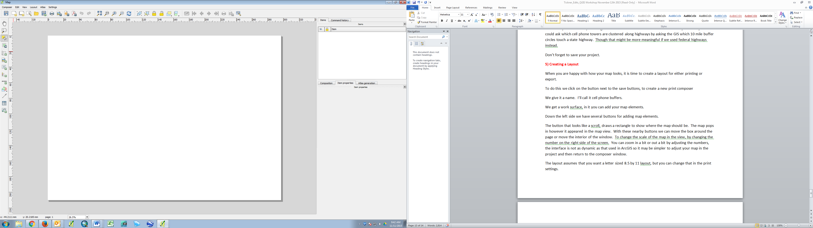
Click the button that looks like a scroll, draw a rectangle to show where the map should be. The map pops in however it appeared in the map view. With these nearby buttons we can move the box around the page or move the interior of the window. To change the scale of the map in the view, change the number in item properties on the right side of the screen or by changing the scale inside the original project window.
The layout assumes that you want a letter sized 8.5 by 11 layout, but you can change that in the print settings.
Another thing we can add is an image. Click the tool, then draw the box that you want the picture to inhabit. In the item properties menu, you would browse to the image file you want to add. This is often done to add a logo or preexisting attribute information.
We may want to add a text box for the title. Draw the box first, then type the text on the right side. You can change the size and style of the font and other properties such as the color and alignment. And you could add a frame around the box.
We can add a legend. Draw the box first, then on the right side of the screen adjust what parts of the legend are displayed. We can remove items we don’t want, and also edit the names of the items we keep.
We can add a scale bar. The GIS knows what the scale of the map is and will create a correctly scaled scale bar.
We can draw a box to give the map a boundary. I’ll send the box to the back and give it some color.
I also recommend adding text that provides attribution of the source of the data and who made the map.
In the course of creating a layout you may decide you want to make changes to the map.
Go back to the map workspace. I wish that the water were blue. Under Other files I’ve added a shapefile for the Great Lakes, we can add that in. We will change the color to blue. I will add Canada also to define the land beyond Lake Superior.
You can add shapes, such as a rectangle to define the title area.
Don’t forget to save your work.

