Download: http://bit.ly/2g42k7Z
If short URL doesn’t work: archive.lib.msu.edu/maps/workshops/QGIS_1_2016.zip
Login info: Teach2me
QGIS Workshop – Making a two variable comparison map
There are three files we will be working with – a Michigan county shape file and two csv spreadsheets. These are in a folder on the desktop… (or available for download with these instructions).
We will be making an additional vector file based on the County Shapefile and joining the spreadsheets to the shape file and the newly created file to create a choropleth map and a graduated symbol to overlay on that map.
- Add the shapefile by clicking the vector + button on the top left of the layer window (circled below).
Browse to the shapefile location, click on it (this is the file with the .shp extension, the other files are associated with the .shp but are not the one to open) and open it, then click open again in the add vector layer box.
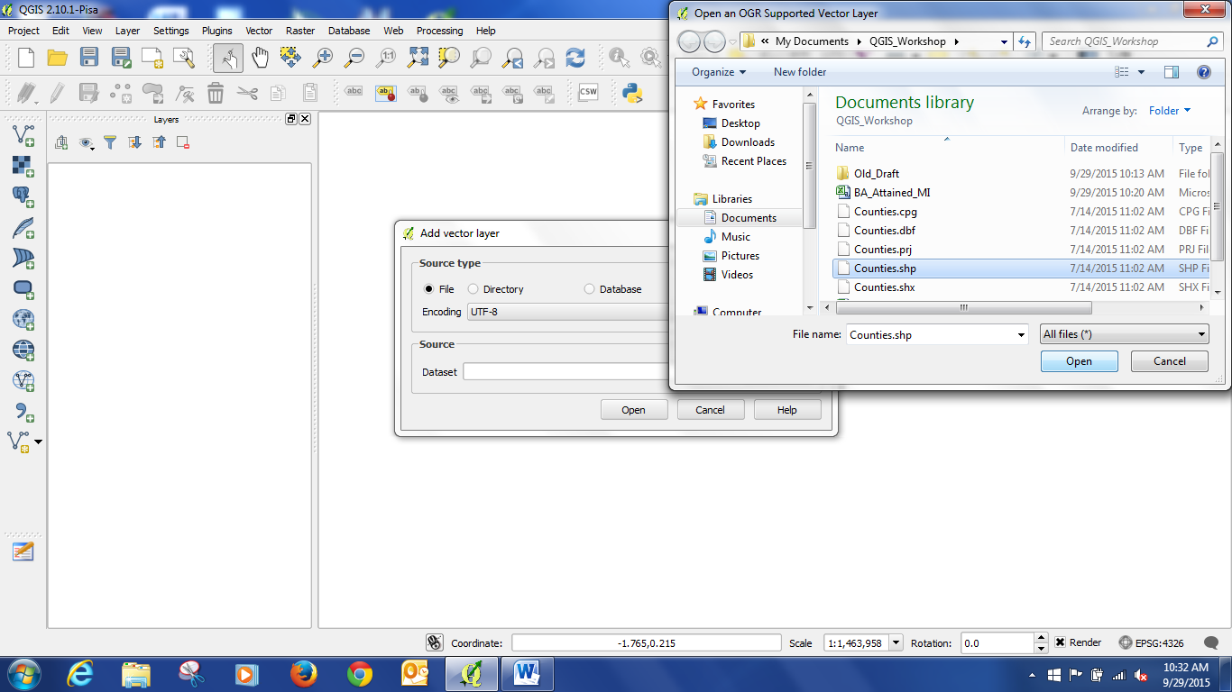
Now you should have the file opened and it should look like this:
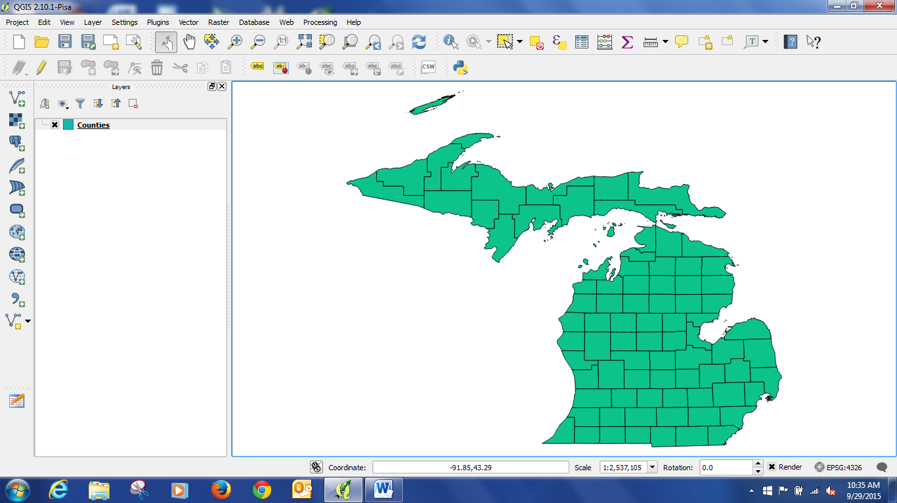
Let’s quickly review some information about this file… right click on Counties in the Layers list, and then click on Properties.
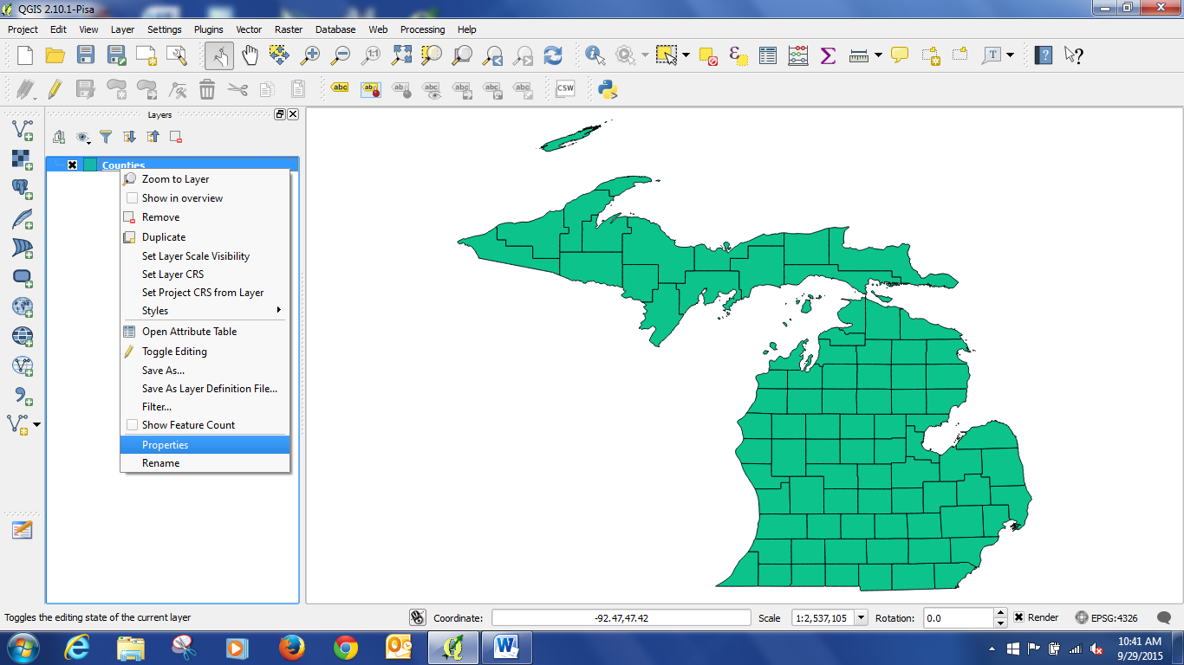
Then click on General.
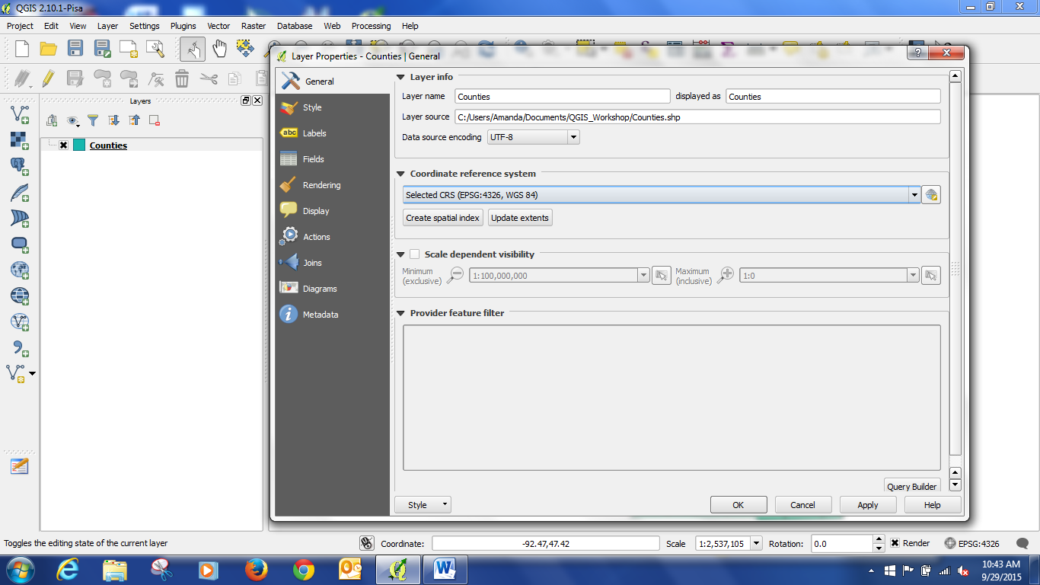
We can see that the coordinate system is WGS 84. This is a typical default coordinate system. It is what was defined by the source of the shapefile, the GIS Open Data Website of the State of Michigan. It is a good practice to review your shapefiles and make sure that you are using an appropriate and matching coordinate system for all your layers.
- Now we will make a centroid layer based on the shapefile. Close the layer properties window. Then click on the Vector menu -> Geometry Tools -> Polygon centroids.
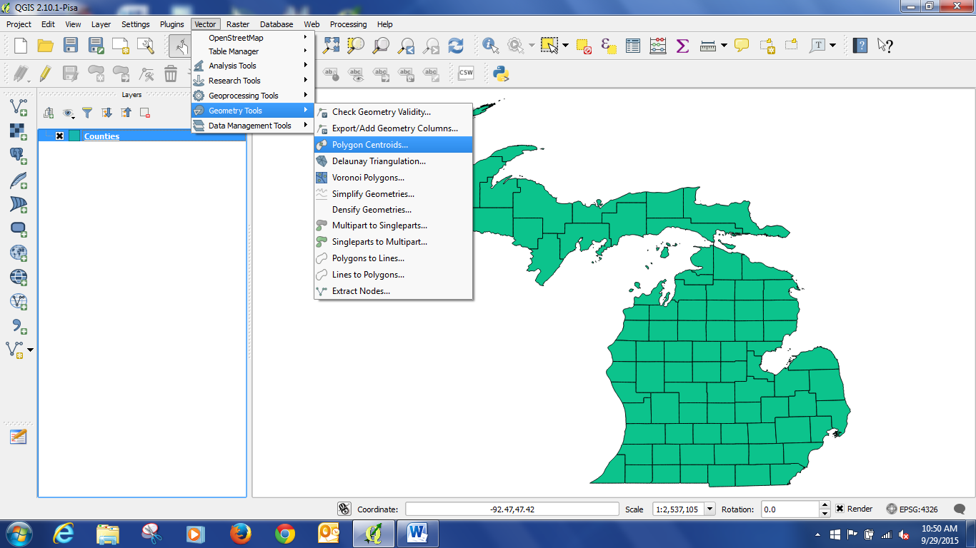
Click browse to select a place to save the new file, and give it a name, “CountyCentroids” Click save in the Save output shapefile window. Then click “Okay.” Now you should have a centroid layer, and your project should look something like this: 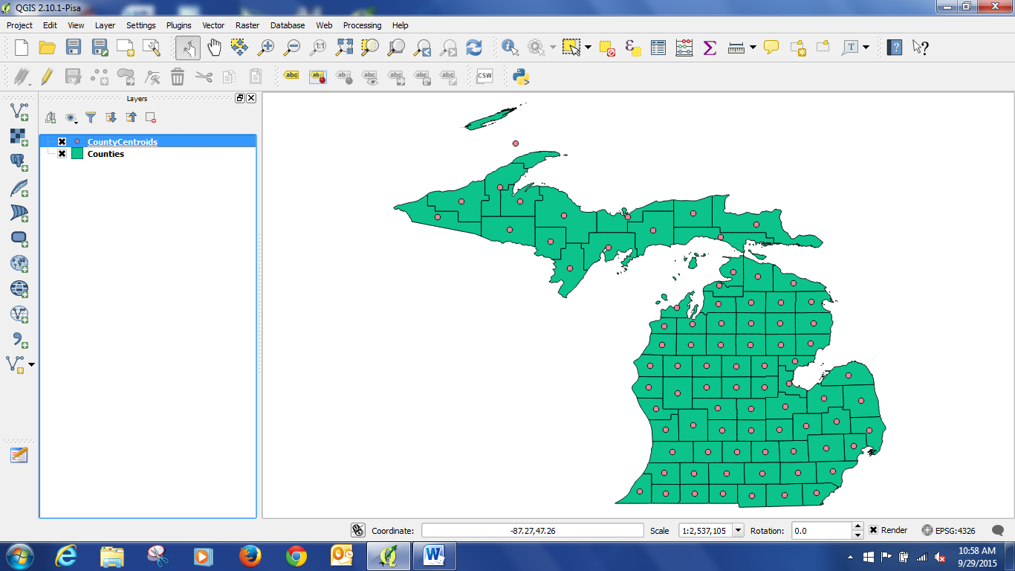
Now would be a good time to save your project. Saving a project does not save changes to individual files, but will save the links to them. Click the Project menus, select save and save your project in the same space as the centroid shapefile. (no screen shot for this)

- Editing the centroid file. Notice that one of the polygons was split –Isle Royale caused the centroid to appear in the middle of the lake. This will not look good for comparison with the other centroids, so we should move it.
Select the CountyCentroids layer by clicking on it.
Then click on the Edit Toggle Button (circled in red).
Then click on the Move Features Button.
Then click on the errant point and move it off the lake onto the county (see arrow).
Once you have it where you want it, click the Save Edits button and toggle Editing off by clicking the Edit Toggle button.
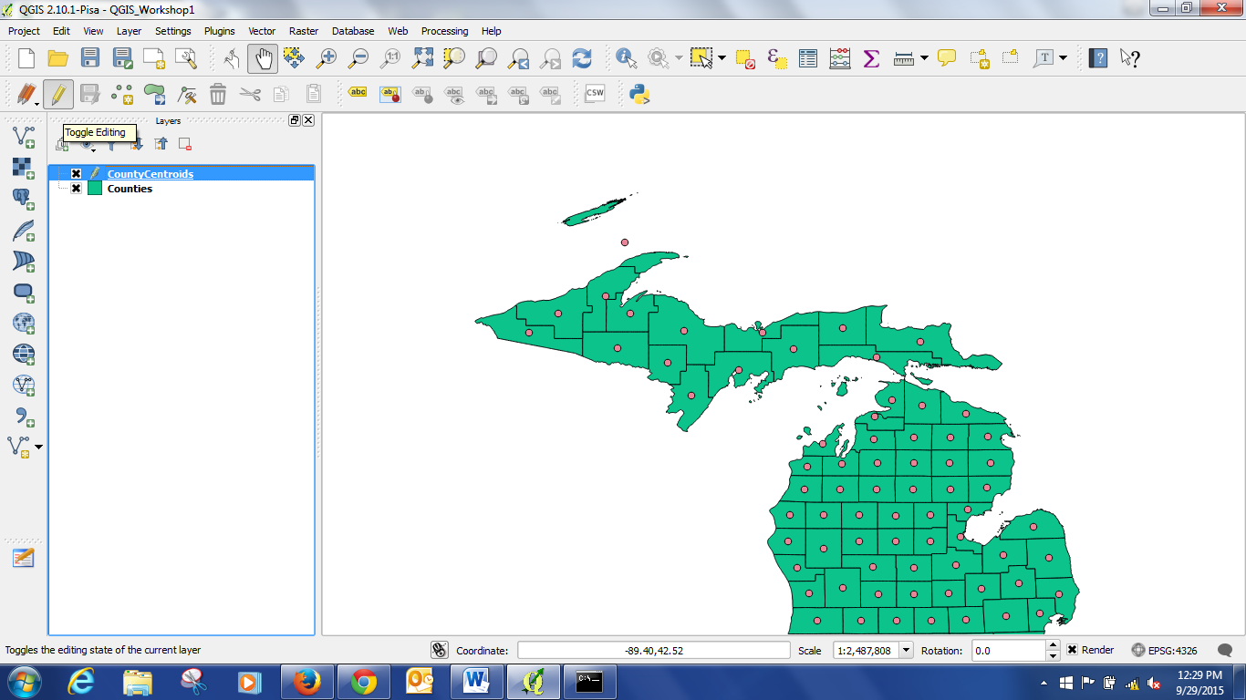

- Now that we have the base layers in place, we need to connect them to some data. We will be comparing median income and percentage of people with bachelor’s degrees. So let’s open the .csv files with that information.
You can do this if you have an excel file by clicking on the add vector data button that we used to add the shapefile. However, I have found that QGIS preserves file headers and format better as csv files. So to add a csv file, click the apostrophe icon at the bottom left of the layers box. Then Browse to the BA_Attained_MI csv file and click Open. Under Geometry definition: click No Geometry (circled).

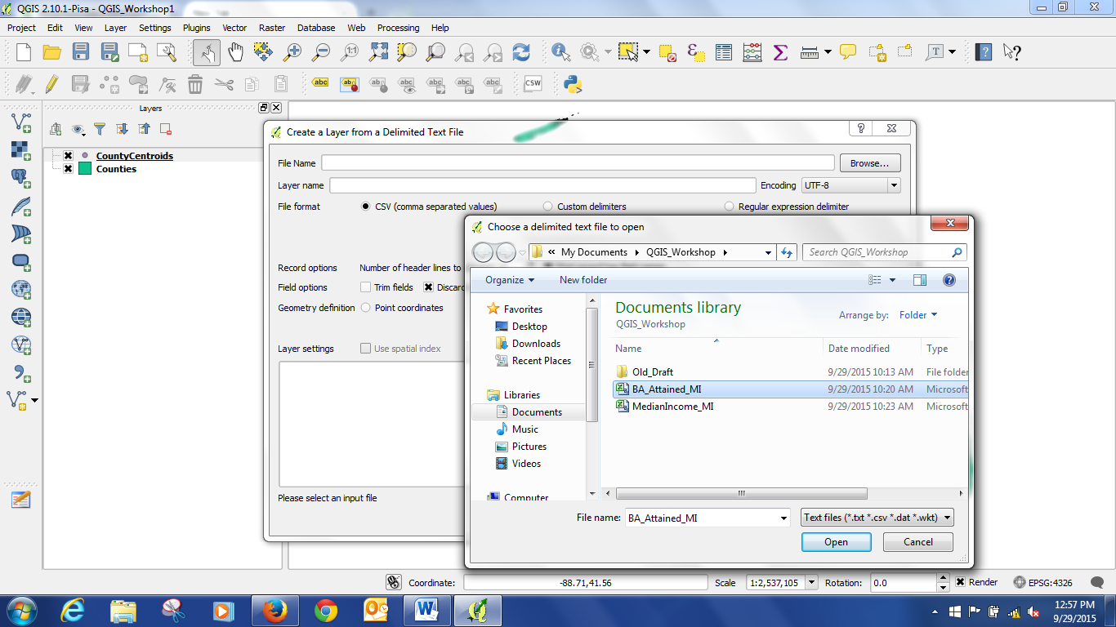
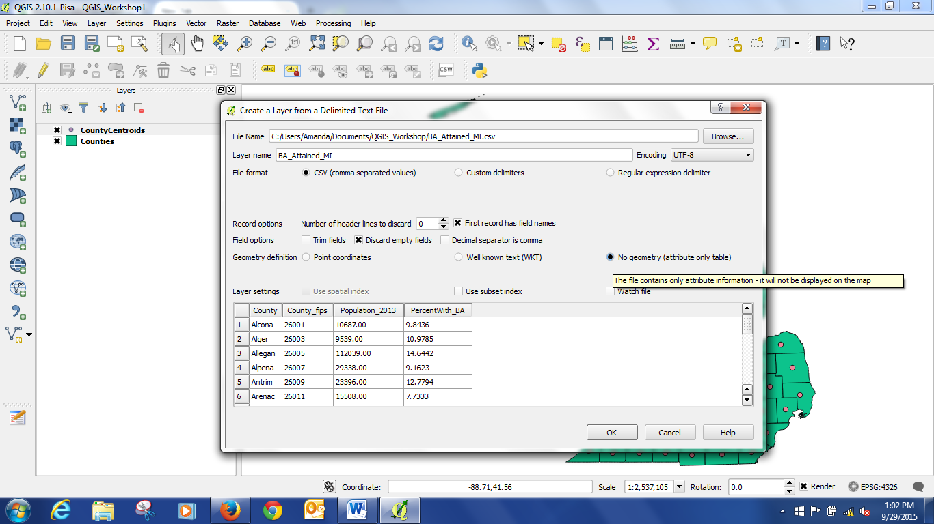

Repeat this process for the second csv, MedianIncome_MI.

We should check that the table fields are in the format we need them to be in. Right click on the MedianIncome_MI layer and click on properties. Then go to the Fields section. The fields should have “double” for the Median income, and “string” for the County name. Double = number with decimal, string = text. Do the same check for the BA_Attained_MI table, “string” for County, “double” for PercentWith_BA. See below for a screen shot.

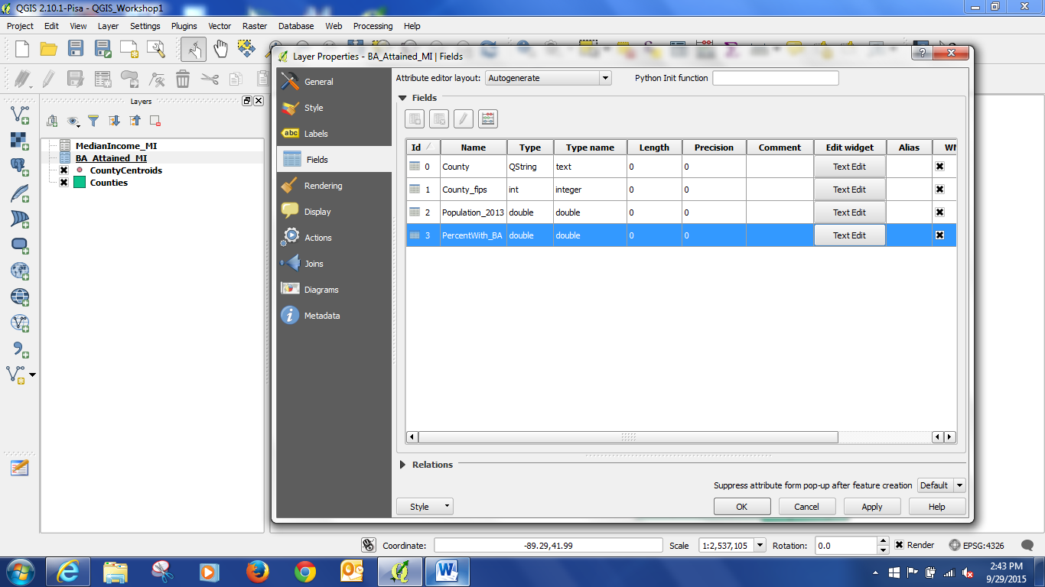

Now that the data is in the project, we can Join the tables to the shapefiles. Joining is a way of connecting shapefiles to data – but you need a common field between the two files to perform the join on. FIPS codes (from the census) are often used for this, but in this case we will just use the county name, from the “County” field in both tables. NOTE: To join tables – you must have perfectly matching fields of the same format (attribute type – string, double, etc.). If you do not, the tables will not join completely and you will have places without data due to the mismatch.

- To join the files: Right click on CountyCentroids and open the Properties box. Click on the Join icon. Then click on the plus icon at the bottom of the box (circled). This will bring up the Add Vector Join box. Make sure BA_Attained_MI is in the Join layer box. Then select County as the Join field, and County as the target field. Click the check box next to choose which fields are joined. This option lets you reduce redundant fields in your join. Then click Custom Name Prefix. Delete the file name, this will prevent QGIS from replacing your headers with the file name instead of something useful. Now if we go to the Fields tab in properties, the two joined fields should show up.

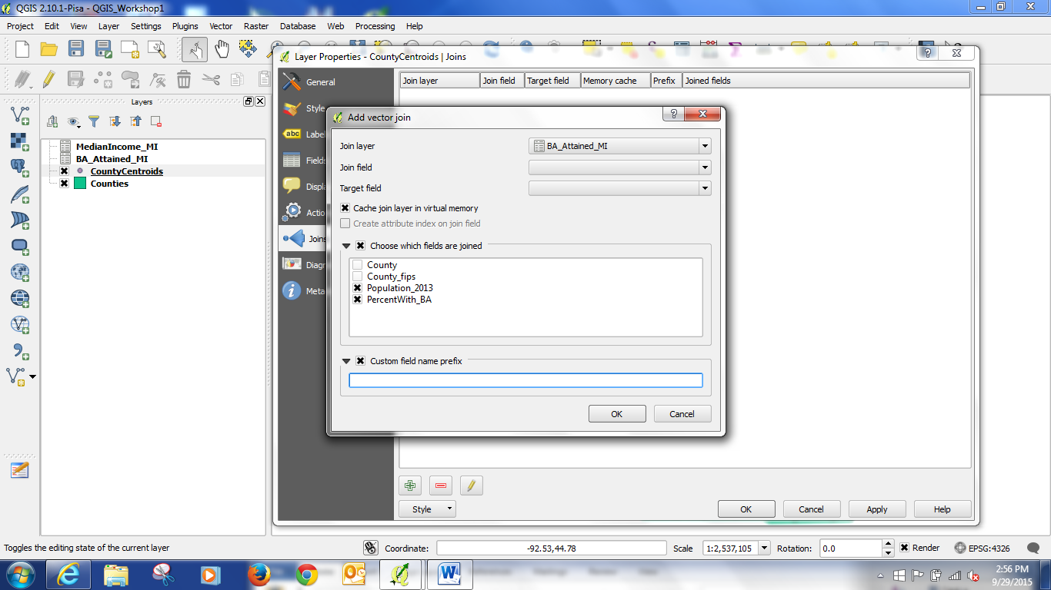

Repeat this process for the Counties and MedianIncome_MI files. Right click on Counties, open Properties. Then choose MedianIncome_MI as the file, Median_Income as the field joined, and delete the custom header.

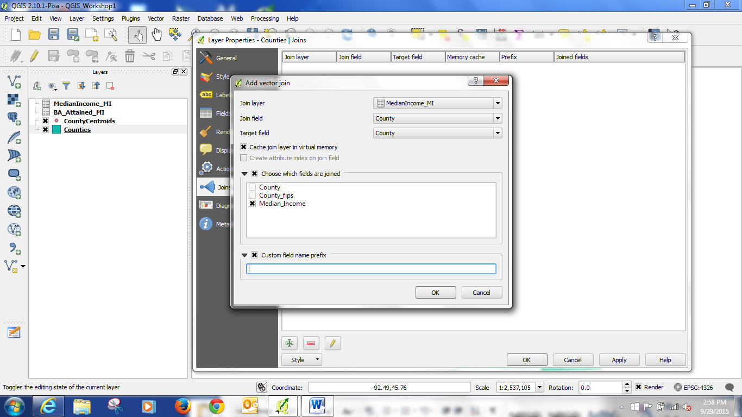

- Now the data is joined. In order to make the join permanent we need to save the layers via “Save As.” Right click on the CountyCentroids, and click on Save As. Then pick a name for the new file – CountyCentroidsJoined. Do the same thing for the Counties file.
- Now the shapefiles with the data to be compared are saved. The old files can now be removed. Right click on the tables and original shape files and click “Remove.” Tell it okay when it asks you if you want to remove the file from the project. NOTE: This does not delete the files. This simply removes them from the project.
- At this point we now have the files we need to make our map visualization. Right click on CountyCentroidsJoined, select Properties, and click on Style. At the top of the box, it will say “Single Symbol.” We want Graduated, so change that. Then under Column, select PercentWit (this is how QGIS messes up your headers by cutting them off, if there is time later I can show you how to fix that). Under Method, select Size. Choose the number of classes as 5. Hit classify. (There are different classification methods which are called modes, we will use the default – Equal Interval) Don’t worry if some look like boxes, that is just the edges of the circles being cut off. Hit Classify to make sure it is using your settings. If you want to change the color, hit the box next to symbol and adjust that. If the size of the symbols is too large, you can reduce the second value of size from. Then hit okay.
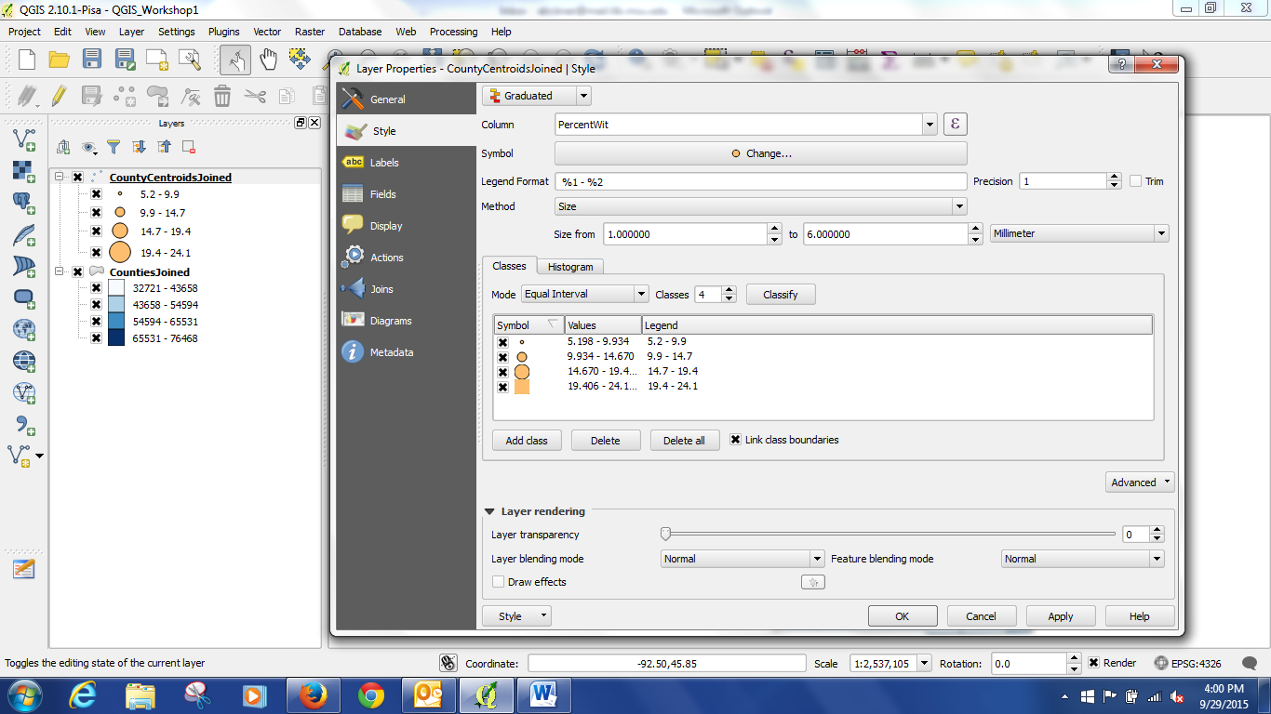
- To make the choropleth, we will follow a similar process. Right click on the CountiesJoined, select Properties, and click on Style. At the top of the box, again change to Graduated. Column = Median_Inc. Method = Color. Mode = Equal Interval. Classes = 5. Hit Classify. If you want to change the color, you can pick a different color ramp under Color ramp. Then hit Okay.
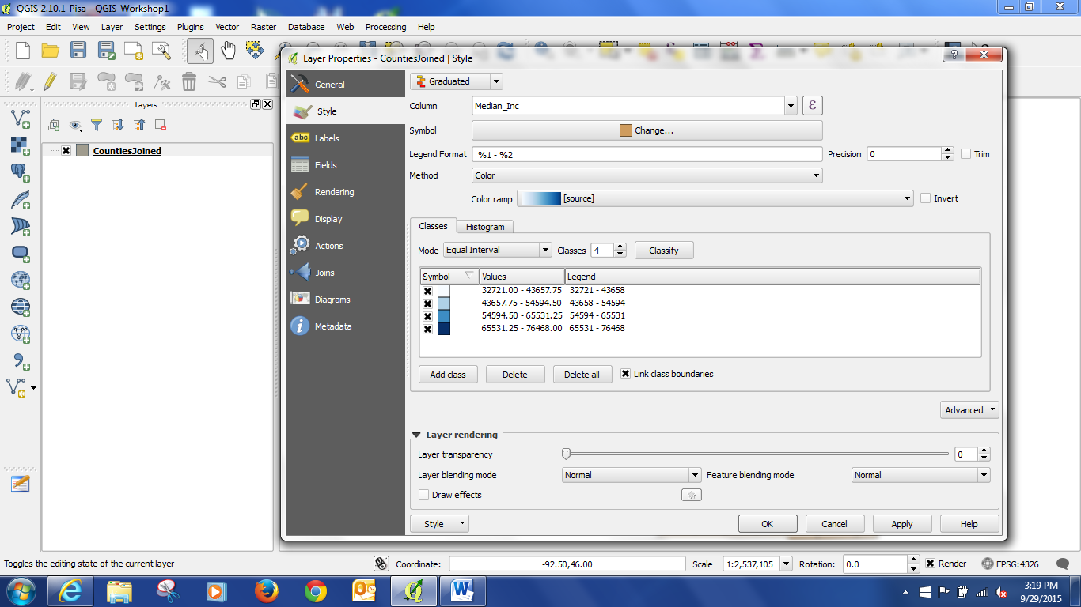
And voila, we have our map.
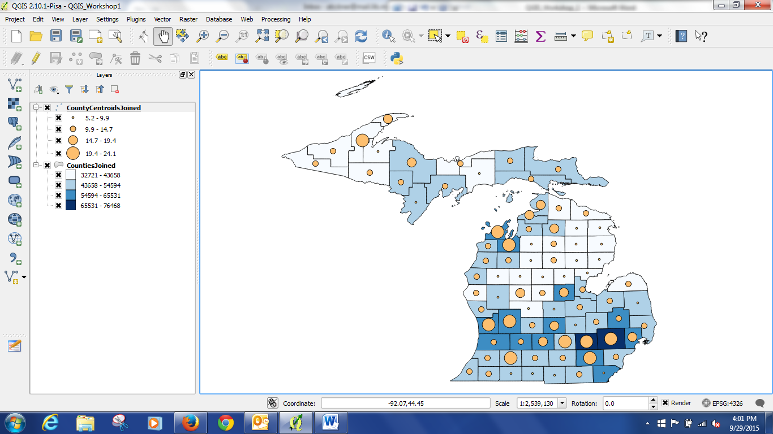
To export your map in a format you can include in a word document, you can go to Project in the menu, and select Save As an Image.
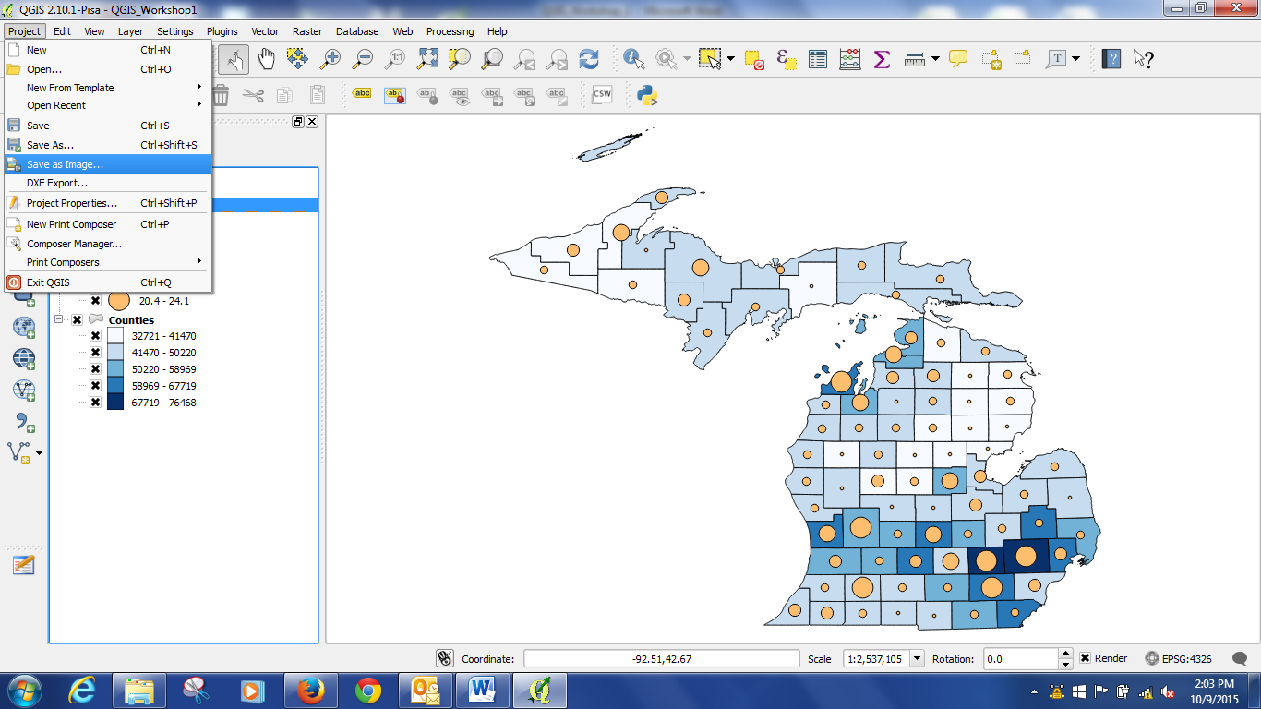

Bonus round: Fixing up your headers.
This involves installing a QGIS plug in. Go to Plugins Manage And Install Plugins. Find Table Manager in the list, click on it, and hit the install button below. Then you should have a table icon (circled below) that you can click on while a layer is highlighted to open an editing table for your attribute table headers, etc. This is also a good way to be able to delete columns you don’t need. Unfortunately, it will not change the field type.
