Georeferencing a Historical Map in QGIS Workshop Instructions
Today we will be georeferencing a historical map and creating a vector file based on that map and other historical and modern sources of the MSU Library building.
Georeferencing is the process of locating a digitized map, aerial photo or other object in “space” – giving it geographic reference coordinates. Essentially, the process is to take an object with known coordinates that has reference points which match the object with unknown coordinates and match the two together. The unknown object is then adjusted to fit. (This adjustment is roughly similar to the process by which Excel or other programs fit a regression line to a scatter plot.)
Once an object has been georeferenced, it can be used in online mapping applications, have features extracted from it and compared to other features, and generally be integrated into a GIS.
- First we need to set our project environment. Go to the Project menu -> Project Properties, and then go to the CRS tab. Click the Enable ‘on the fly’ CRS transformation. Then type WGS 84 Pseudo Mercator in the Filter box. Select the WGS 84 Pseudo Mercator projected system and hit “Apply.” This will set the reference system for the project.

WGS 84 Pseudo Mercator is a good “average” projection and one that is typically used for web applications. If you are doing more careful analysis, selecting a projection that is suitable for your area is a good idea.
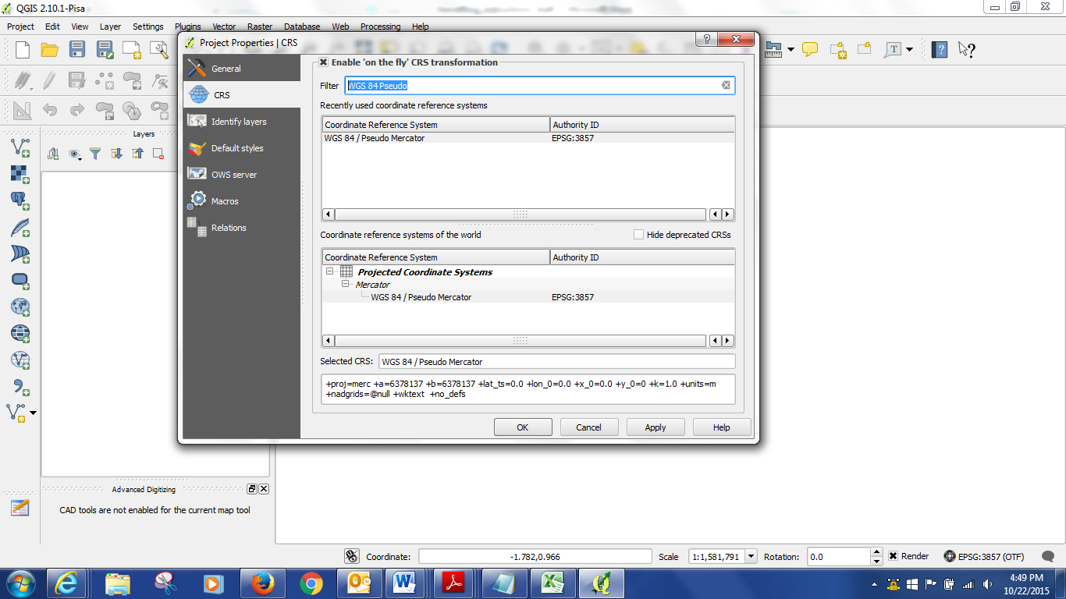
- The next step is to open a base raster map which has spatial information that we will georeference to. We will use a base map that I georeferenced ahead. There are built in base maps in QGIS and these could also be used. Use the open raster map tool (the grid icon on the left) to Open the MSU_Basemap file. There are circles on this map that have been added to use as guides in the upper part of the campus – zoom to that area using the magnifying glass.
- Next open the object we will be georeferencing in the georeferencing tool. This is a 1926 Sandborn map of campus, in .pdf form (I would not recommend .pdf for most applications, but it is interesting that QGIS will work with .pdf and it can be convenient). Go to the menu Raster -> Georeferencer and a window will appear. [Note: if you don’t have the Georeferencer option, you will need to go to Plugins and install the GDAL Georeferencer plugin, and possibly restart QGIS] Within that window, add your raster by clicking on the Add Raster (the gridded icon). There will be a pop up window which asks you to select a coordinate system, choose WGS 1984 Pseudo Mercator under “Recently Used Coordinate Systems” and click okay. The map with circled areas should appear in the window.
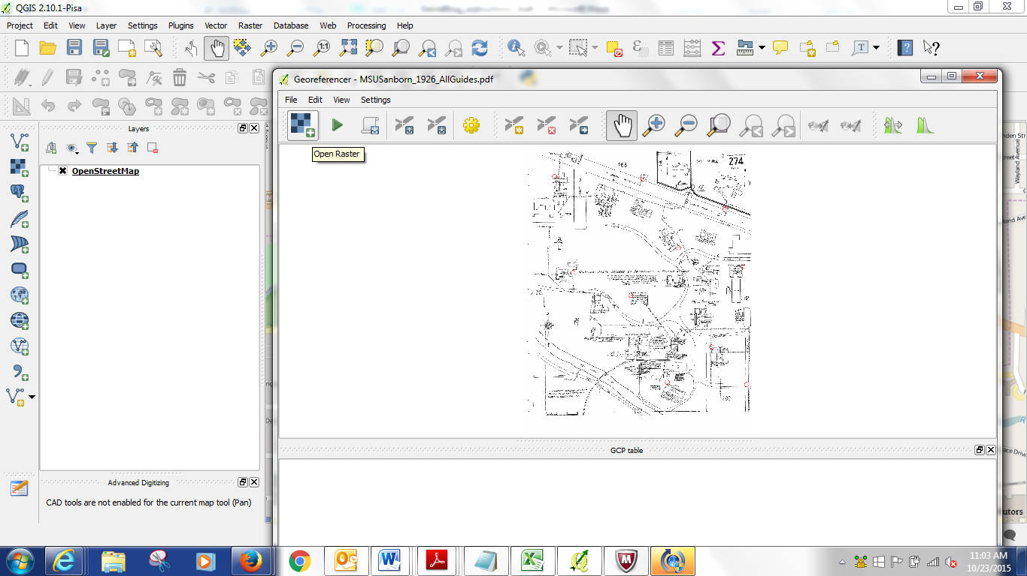

- Next we will add some Control Points. These points will match up the two maps. Zoom to Campbell Hall in the upper left of the map in the Georeferencing window. Click on the Add Point Button and then click in the circle on the corner of the building. It will say add coordinates. Which we don’t have, so select “From Map Canvas.” The Georeferencing window will minimize and you can pick the matching point on the basemap – zoom to Campbell Hall on the base map and add a point in the same corner. If you control point adding tool disappears, restore your georeferencing window and hit From Map Canvas again. When you have numbers in your X and Y in the Georeferencing window, hit okay.
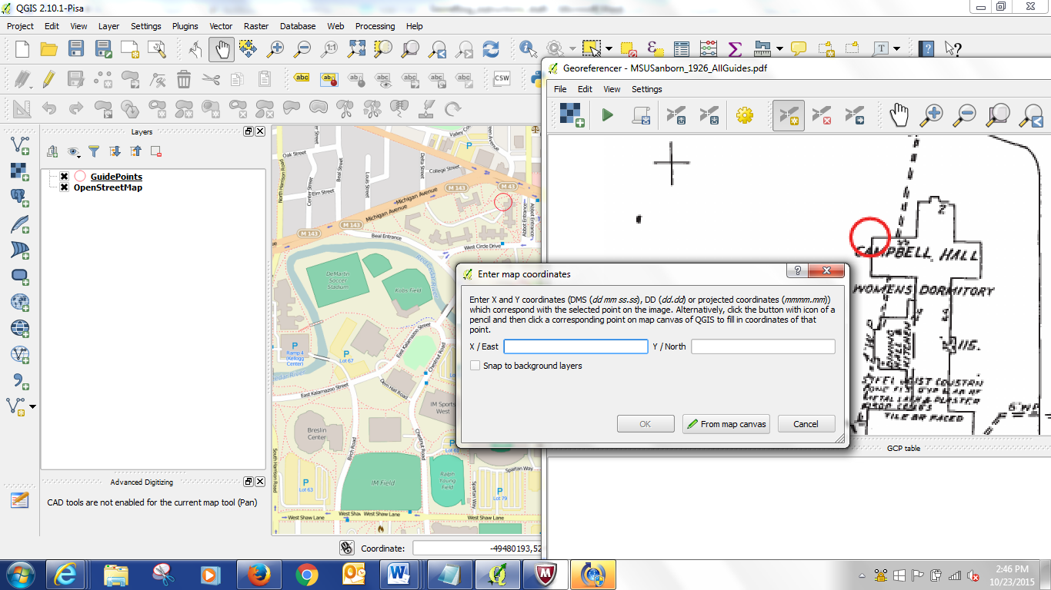

Follow the same procedure with the other circled areas. You can use the hand tool and the zoom in and out tools to adjust the view of the maps.

If you want to return to the whole map that you are Georeferencing, hit View -> Zoom to layer in the Georeferencer window.

After we have added some points, we should save them in case we want to close the project or the project crashes. Click on the Save Points As button and save your points (this will be a text file). This way you can upload them again if there is a problem.

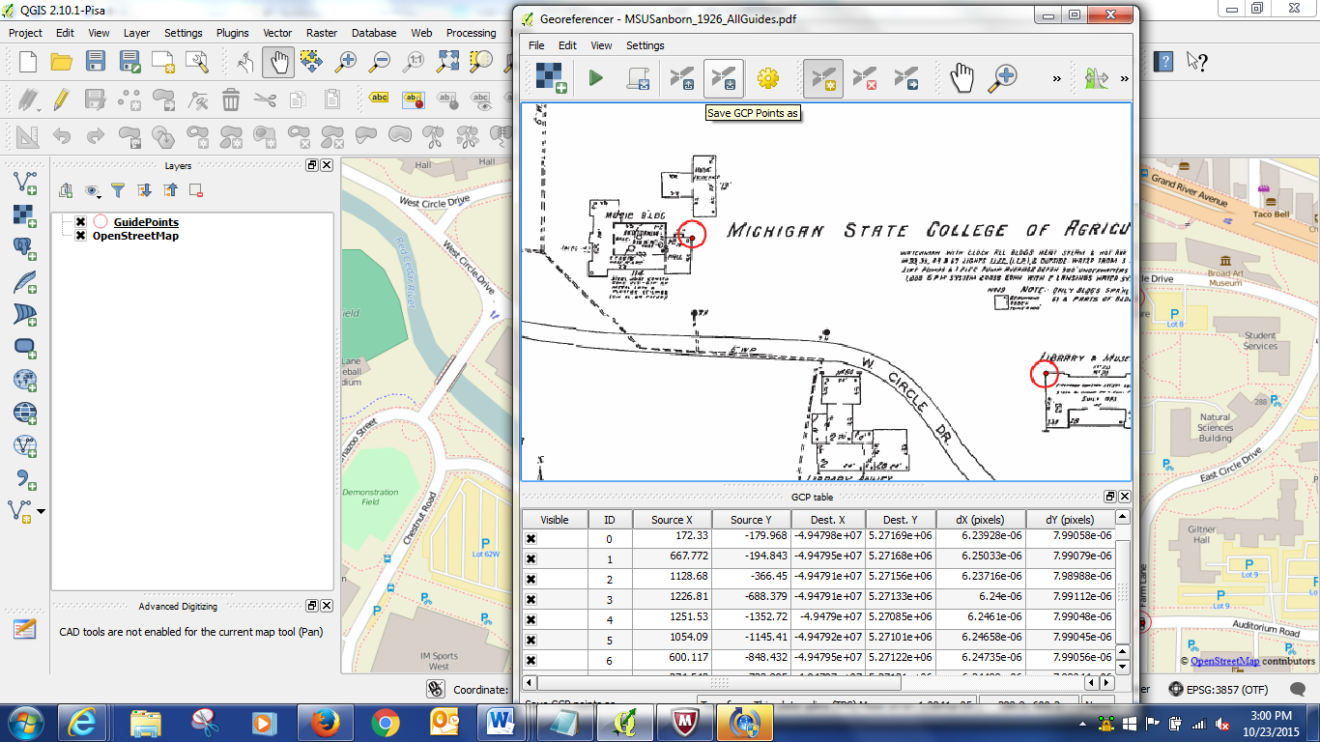

- Now we can georeference the map. Hit the Green Arrow icon. It will ask you to name your output file and set your Transformation settings.

Transformation type: Thin Plate Spline
Sampling type: Nearest Neighbor
Target SRS: Project CRS (WGS 84 Pseudo Mercator)

Name the output file and make sure it is showing up in your work folder.

Check the Load In QGIS When Done button.

Click Okay.
Then click the Green Arrow again to run the Georeferencing.
- Next we will create a new vector layer which will be a collection of features from a series of maps over time to show one way of using historical raster maps.

Add another raster to your project, click the Open Raster button and select the aerial photo file which has already been georeferenced. Then we will have three layers – our Sanborn map from 1926, our aerial photo from 1956, and the modern Open Street Map Base Map.

Now we will create a new shapefile to hold our tracing of features. Click on Layer -> Create Layer -> New Shapefile Layer. Make sure you select POLYGON for type, not the default point.

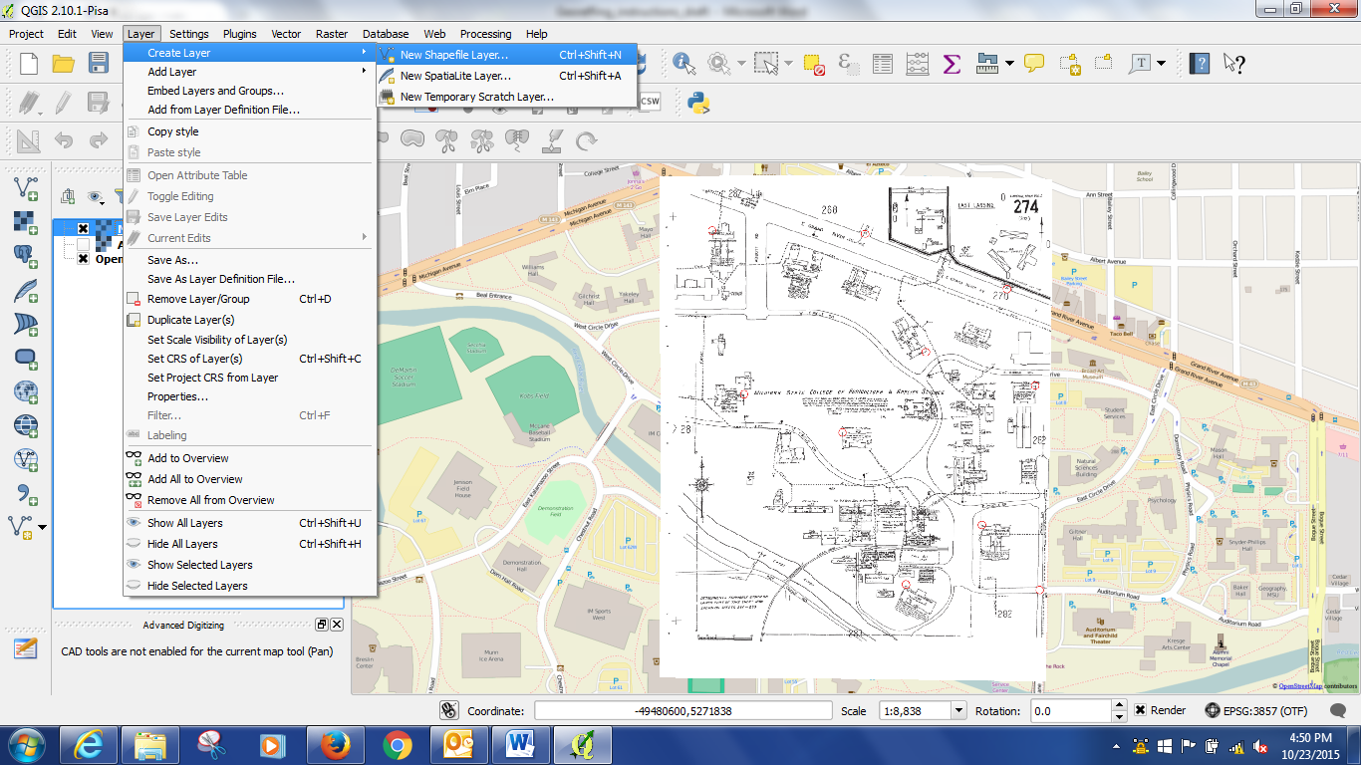

Then we will add an ATTRIBUTE – YEAR. Under New attribute type Year and Type = Whole Number, and hit Add to attributes list.

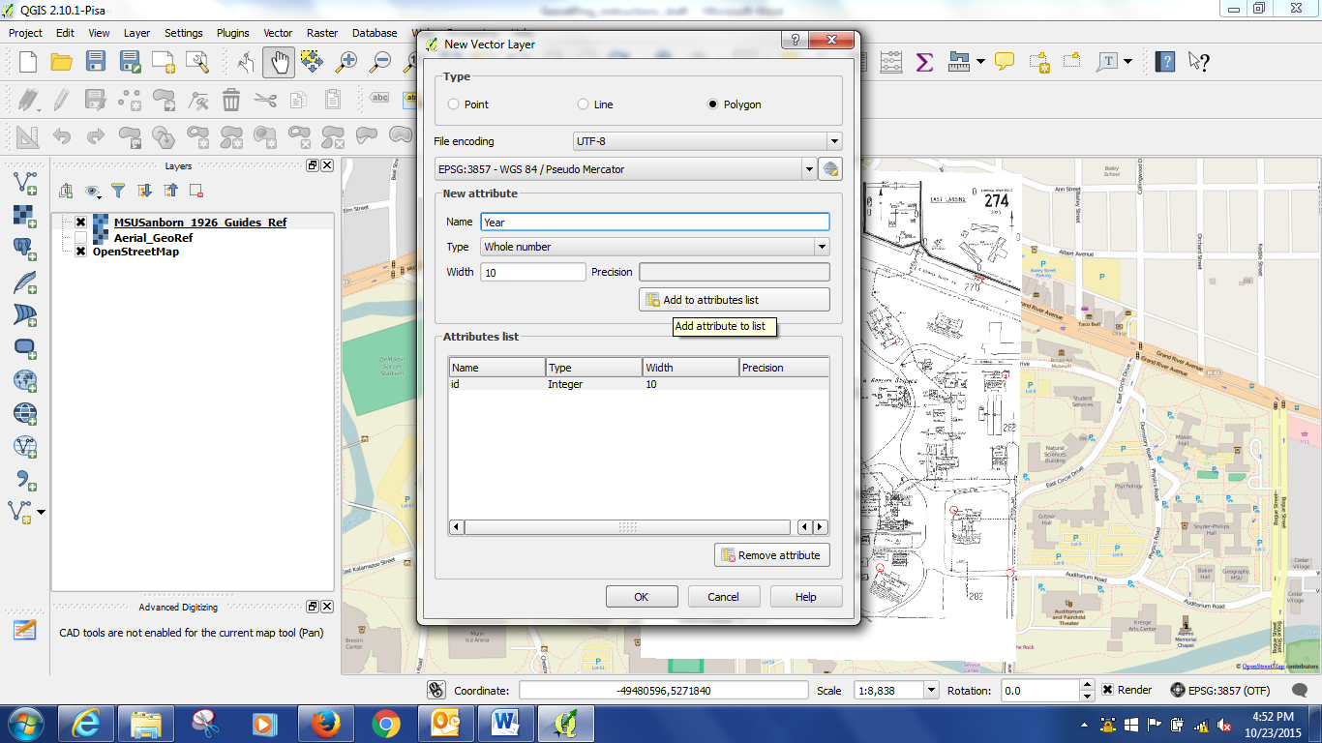

Then name the new shapefile “LibraryFootprint.”
Make sure your new layer LibraryFootprint is highlighted, and Toggle editing ON by clicking the Pencil Icon. This will let us add new polygons.
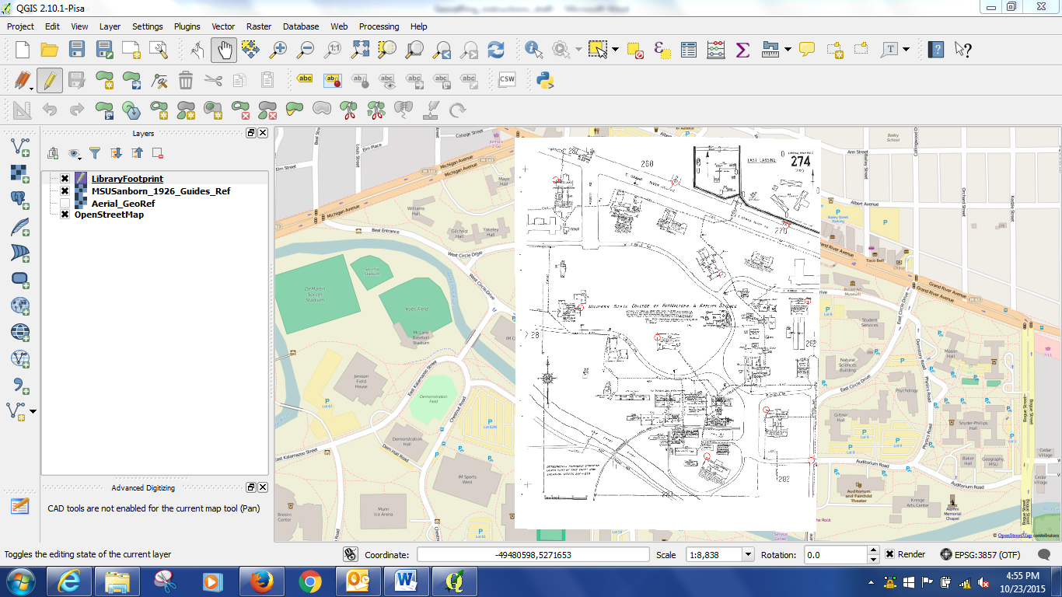

Zoom to the Library on the Sanborn Map layer, click the Add Feature button and trace the library. The map may be pixelated, but just do the best you can.
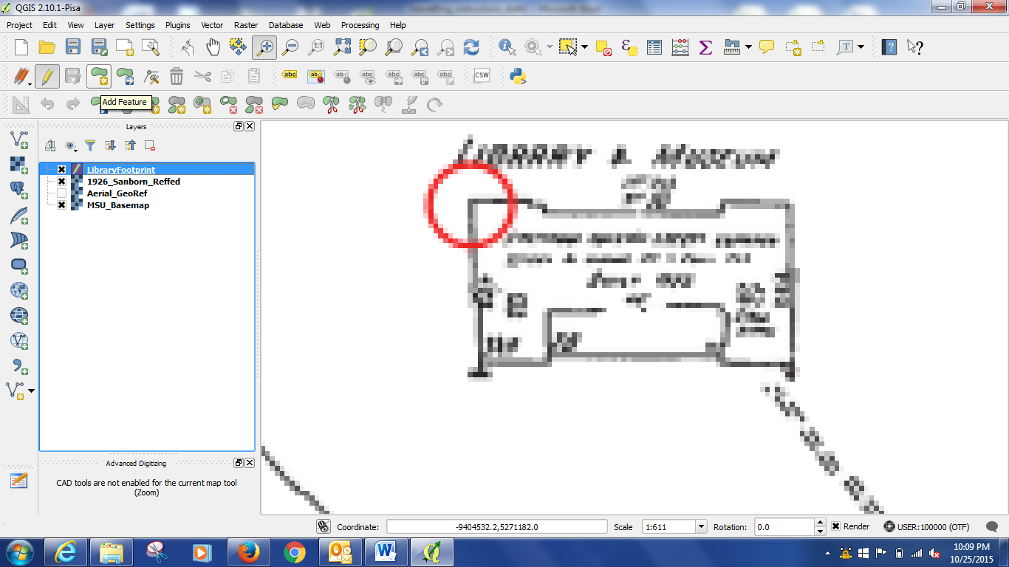
When you are done, double click and under the Year attribute field put 1926.
Hit Save Edits when you have your first polygon.
Then turn off the Sanborn layer, and turn on the Aerial photo layer.
Right click on the aerial photo layer and hit zoom to layer.
Then select your polyon layer again – highlight it. Make sure Add Feature is still selected. Now we will trace the library on this aerial photo layer.
Then do the same thing on the base map – this will over lap the aerial map polyon.
After we have added all the polygons, save the layer by clicking the save button and toggle off the editing button.
- Now we will see how the area of the library building has changed over time. Right click on the LibraryFootprint layer, and select Properties. Then go to the Fields tab and hit the Field Calculator button.
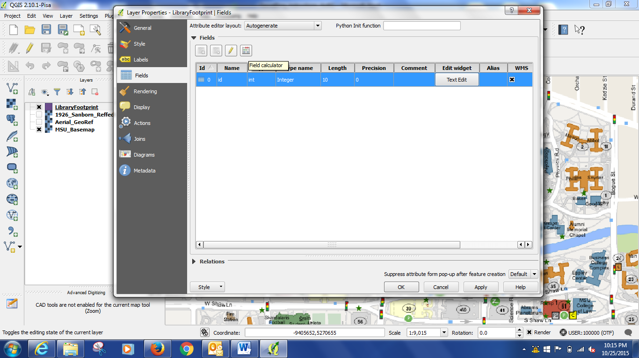
Make sure Create A New Field is checked, name the new field “Area”, Select Double as Output Field Type and Click to expand the Geometry functions under functions. Double click $area. Hit Okay.
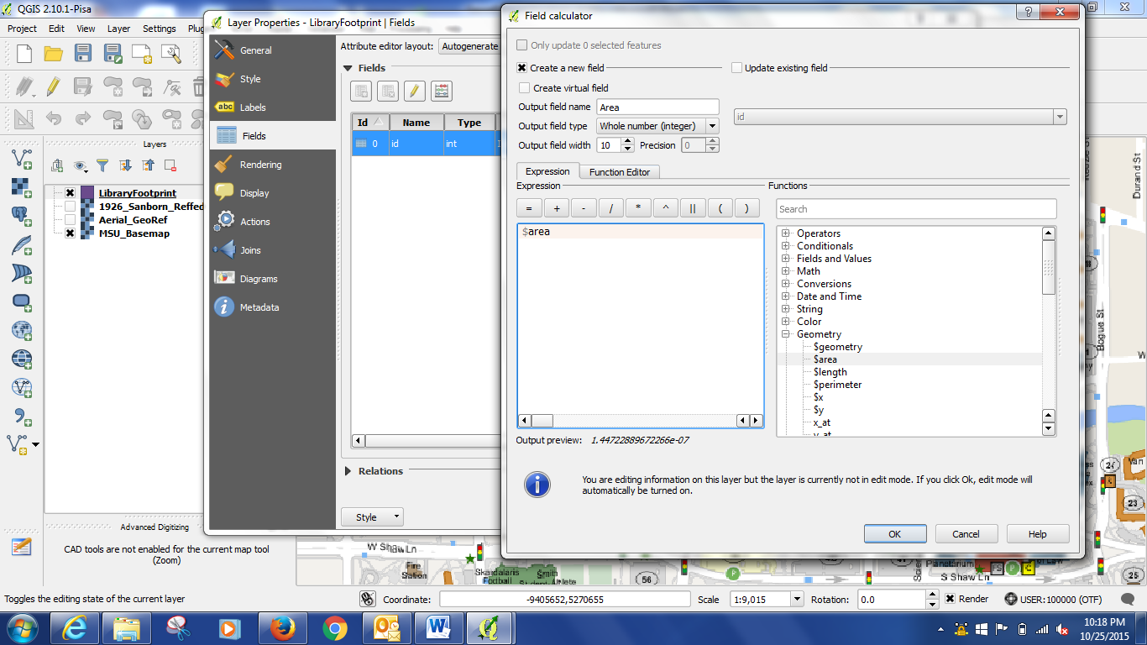
Close the Properties window.
Now Right Click on the LibraryFootprint layer and select Attribute table. The Area field should now appear.
- Another way to do this – and to check to see if the calculation worked properly – is to use the Measure tool, which is an on the fly way of measuring things on your maps/photos.
