Georeferencing a Historical Map in QGIS Workshop Instructions
Today we will be georeferencing a historical map and creating a vector file based on that map and other historical and modern sources of the MSU Library building.
Georeferencing is the process of locating a digitized map, aerial photo or other object in “space” – giving it geographic reference coordinates. Essentially, the process is to take an object with known coordinates that has reference points which match the object with unknown coordinates and match the two together. The unknown object is then adjusted to fit. (This adjustment is roughly similar to the process by which Excel or other programs fit a regression line to a scatter plot.)
Once an object has been georeferenced, it can be used in online mapping applications, have features extracted from it and compared to other features, and generally be integrated into a GIS.
- First we need to set our project environment. Go to the Project menu -> Project Properties, and then go to the CRS tab. Click the Enable ‘on the fly’ CRS transformation. Then type WGS 84 Pseudo Mercator in the Filter box. Select the WGS 84 Pseudo Mercator projected system and hit “Apply.” This will set the reference system for the project.

WGS 84 Pseudo Mercator is a good “average” projection and one that is typically used for web applications. If you are doing more careful analysis, selecting a projection that is suitable for your area is a good idea.
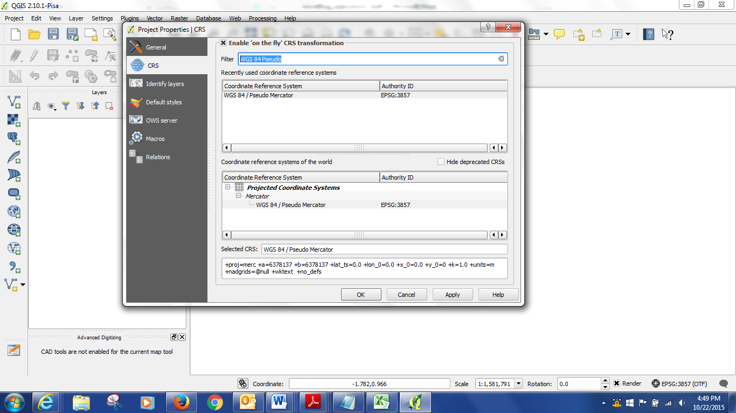
- The next step is to open a base map which has spatial information that we will georeference to. We will use the built in web based base map options. If you click on Web, there should be some choices. The one that seems to work the most consistently is Open Street Map.
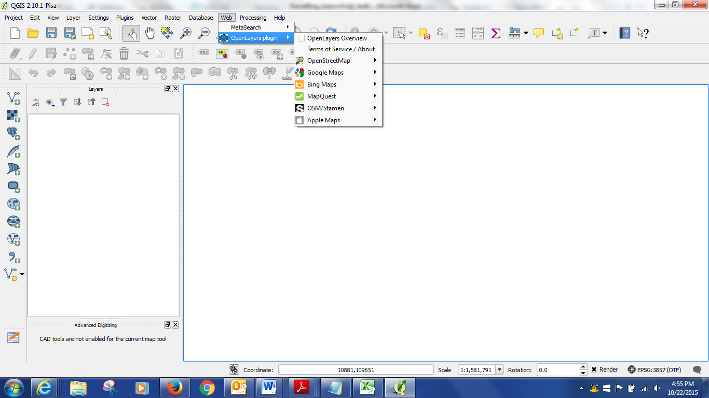
If you do not have a Web option in your menu – you can select Open Web Map in Manage and Install Plug Ins and install it.
Zoom into MSU campus (this is the area we will be georeferencing) using the Zoom magnifying glass and the hand tool to adjust the map.
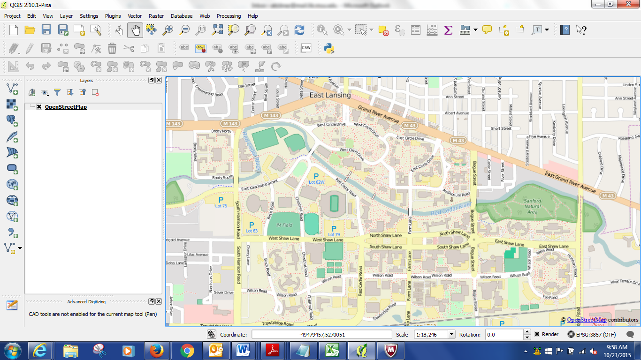
- Next open the object we will be georeferencing in the georeferencing tool. This is a 1926 Sandborn map of campus, in .pdf form (I would not recommend .pdf for most applications, but it is interesting that QGIS will work with .pdf and it can be convenient). Go to the menu Raster -> Georeferencer and a window will appear. [Note: if you don’t have the Georeferencer option, you will need to go to Plugins and install the GDAL Georeferencer plugin, and possibly restart QGIS] Within that window, add your raster by clicking on the Add Raster (the gridded icon). There will be a pop up window which asks you to select a coordinate system, choose WGS 1984 Pseudo Mercator under “Recently Used Coordinate Systems” and click okay. The map with circled areas should appear in the window.
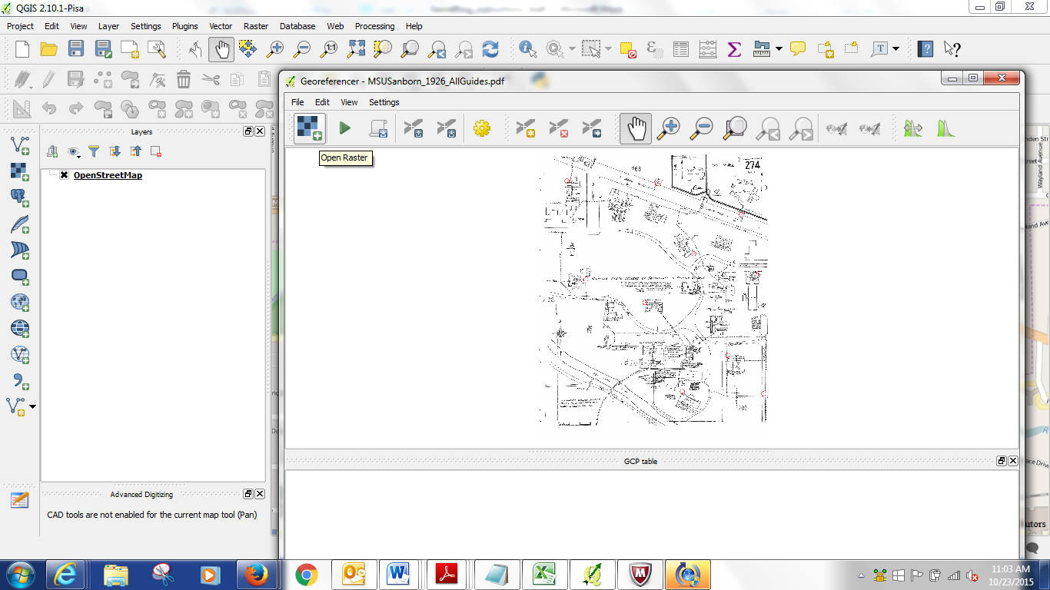
- If you want extra help, open the vector file called “Guide_Points” by clicking the add vector button (top left of the layers list). This will provide circles on the base map which will match the ones on the map to be georeferenced.

(You can minimize and restore the georeferencing window within the program at anytime)

Next we will add some Control Points. These points will match up the two maps. Zoom to Campbell Hall in the upper left of the map in the Georeferencing window. Click on the Add Point Button and then click in the circle on the corner of the building. It will say add coordinates. Which we don’t have, so select “From Map Canvas.” The Georeferencing window will minimize and you can pick the matching point on the basemap – zoom to Campbell Hall on the base map and add a point in the same corner. If you control point adding tool disappears, restore your georeferencing window and hit From Map Canvas again. When you have numbers in your X and Y in the Georeferencing window, hit okay.
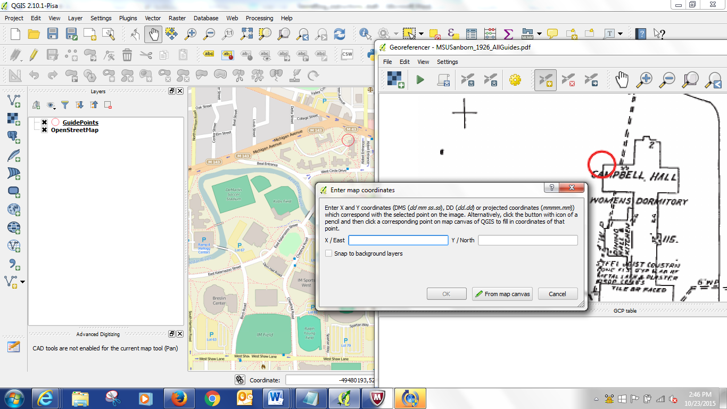

Follow the same procedure with the other circled areas. You can use the hand tool and the zoom in and out tools to adjust the view of the maps.

If you want to return to the whole map that you are Georeferencing, hit View -> Zoom to layer in the Georeferencer window.

After we have added some points, we should save them in case we want to close the project or the project crashes. Click on the Save Points As button and save your points (this will be a text file). This way you can upload them again if there is a problem.

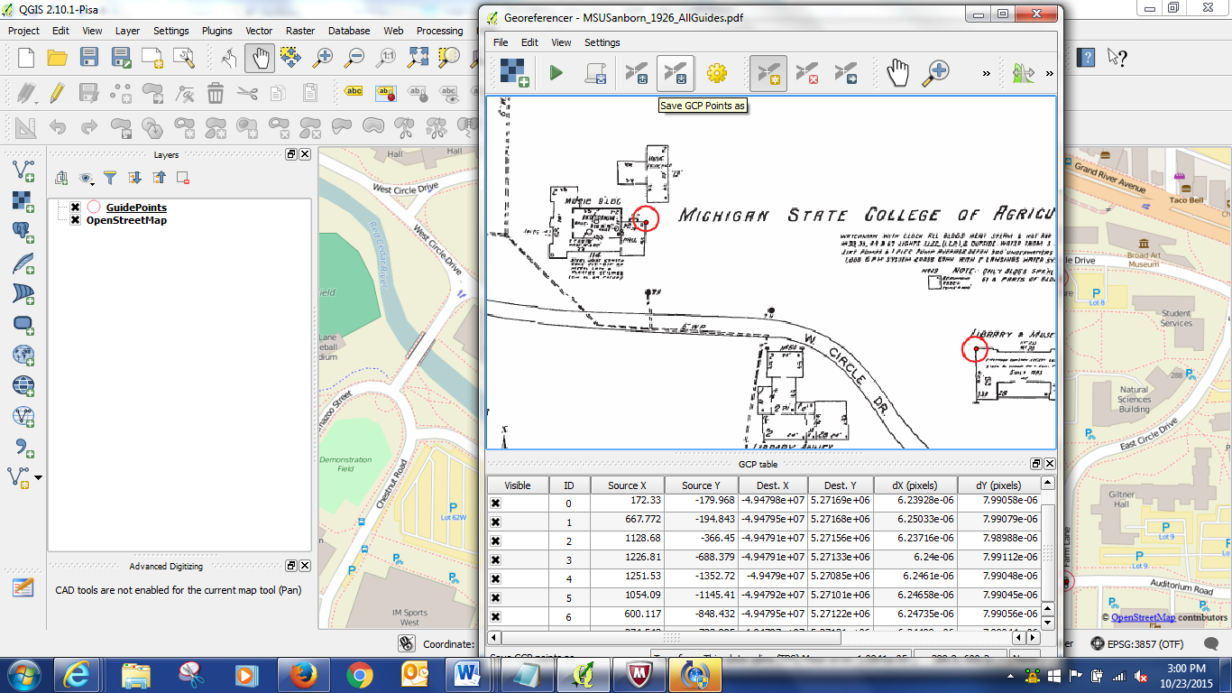

- Now we can georeferenced the map. Hit the Green Arrow icon. It will ask you to name your output file and set your Transformation settings.

Transformation type: Thin Plate Spline
Sampling type: Nearest Neighbor
Target SRS: Project CRS (WGS 84 Pseudo Mercator)

Name the output file and make sure it is showing up in your work folder.

Check the Load In QGIS When Done button.

Click Okay.

- Georef that [NEED TO NOTE THAT IF GEOREFERENCER IS NOT PRESENT, ADD IT FROM PLUG INS]
- Trace a vector of library foot print – Sandborn, then aerial, then basemap
- Load already georefed aerial – indicate the library on there
- Show them where we picked points for aerial – talk about aerials generally…
- Then show vector of Sandborn 26 on aerial 56 (basemap?)
- Use measuring tool – distance and area
- Field calculator – add new area field
- Aerial photo – transparency – bring it all together…

