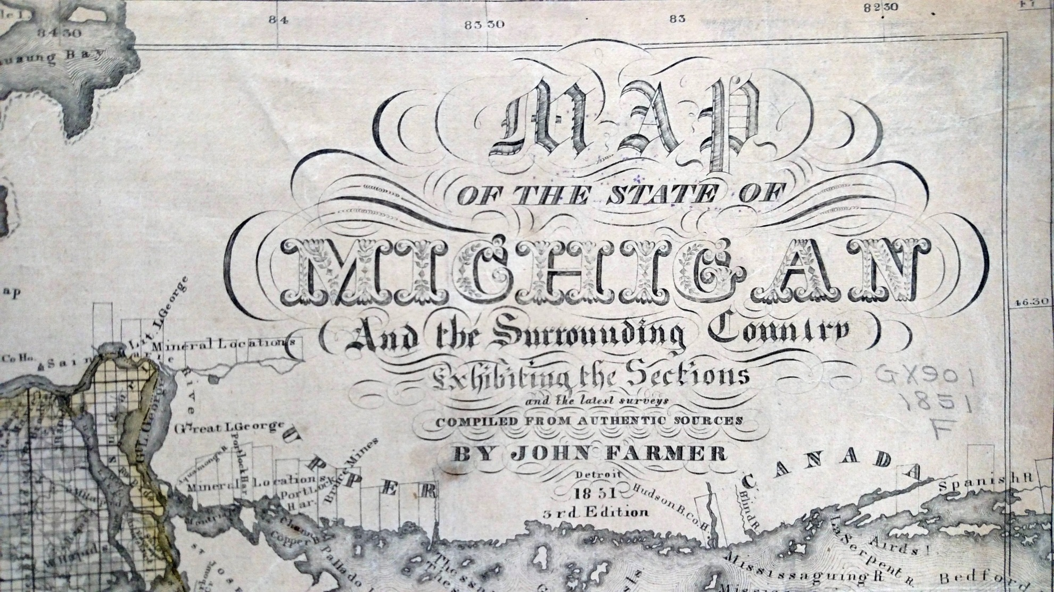
1851-Cartouche
Courtesy of Wisconsin Historical Society

