Golf Map Symbols
Category: | Flags: | Symbol Style 1: | Symbol Style 2:
100 Greatest | 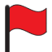 | 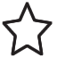 | 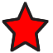
100 Greatest Seeking | 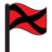 |  | 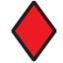
2nd Greatest 100 | 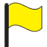 | 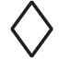 | 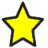
2nd Greatest 100 Seeking | 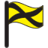 | 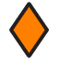 | 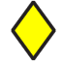
Top 100 Public |  | 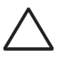
Top 100 Public Seeking | 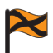 | 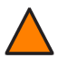 | 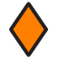
Ranked in State | 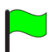 | 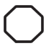 | 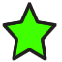
Ranked in State Seeking | 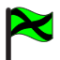 | 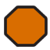 | 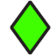
Unranked | 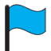 | 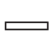 | 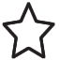
Unranked Seeking | 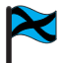 | 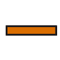 | 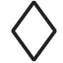
Canada
Canada Seeking | 