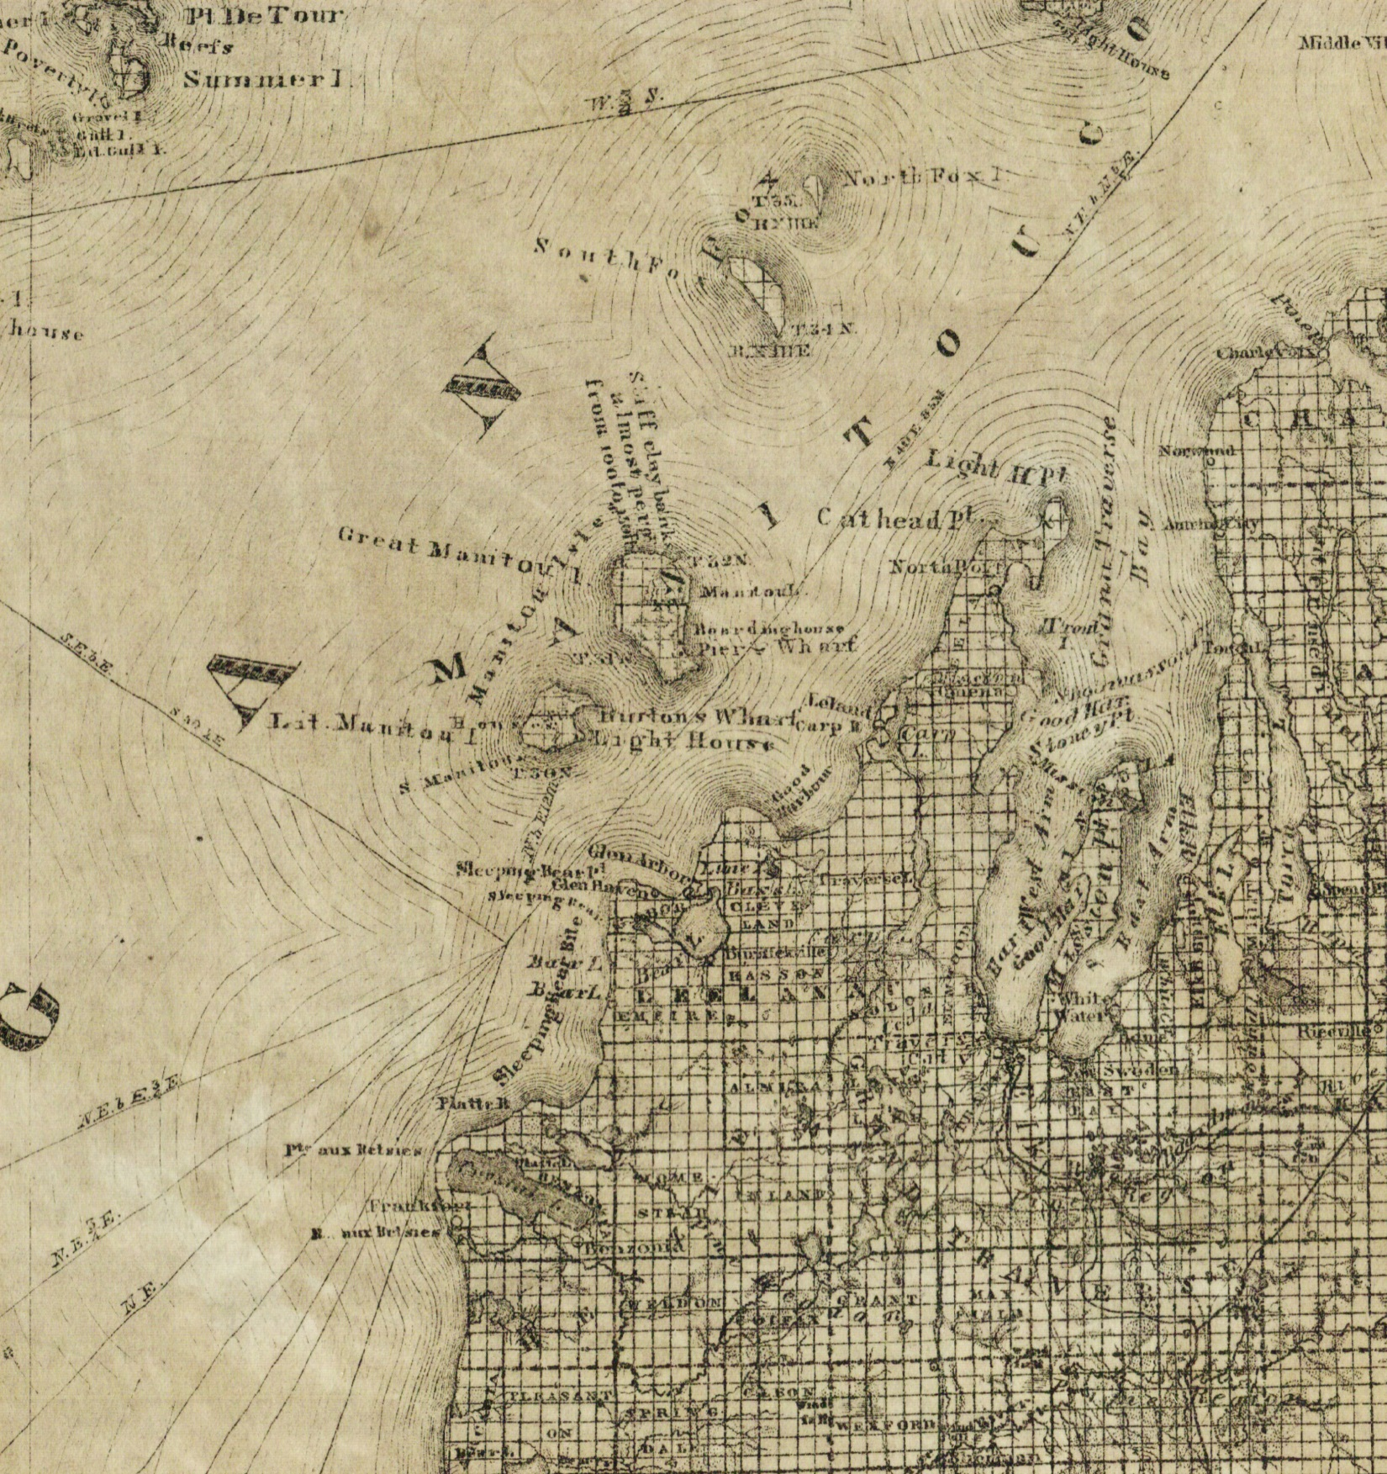

1873c-GT-crop-Clarke

