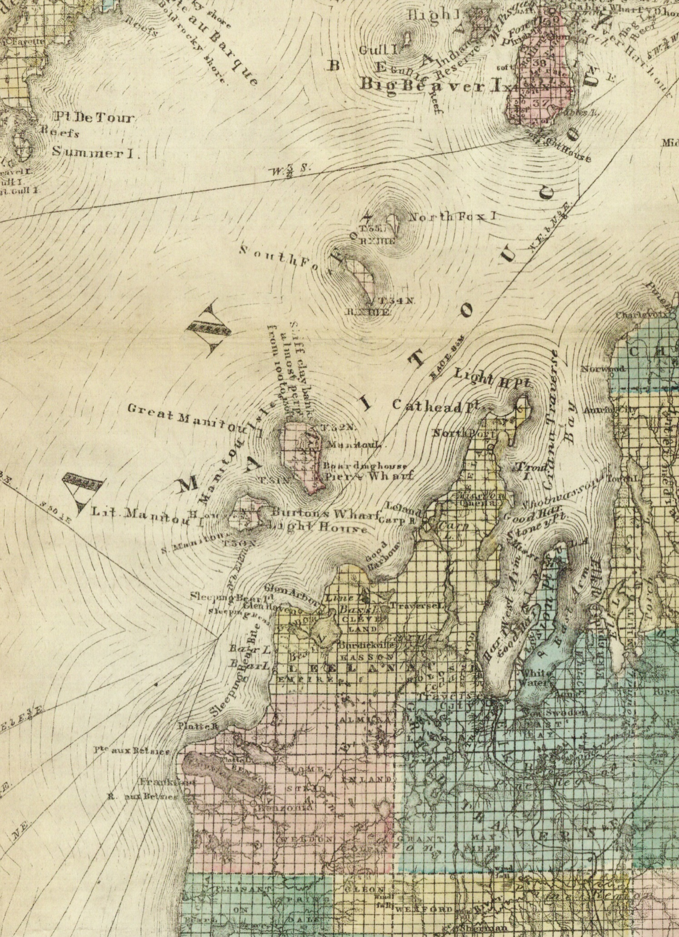
1873a-GT-crop-Clarke

