Mary Anne Walker
Fall 2015

Identify Funding Sources

Research funding opportunities and consider less competitive sources of funding

Apply to several different sources:
FELLOWSHIPS: Federal Government
– National Science Foundation Graduate Research Fellowship
Program (GRFP)

– NASA Harriett G. Jenkins Predoctoral Fellowship Program
– Environmental Protection Agency's Science to Achieve Results
(STAR) Fellowships for Graduate Environmental Study

– the U.S. Education Department's Jacob K. Javits Fellowships
Program
– USAID Donald M. Payne International Development Fellowship
- Fulbright Schuman
Foundations (Beckman, IBM, Rockefeller, Mott, Dow, Hertz, Ford, Carnegie, Kress)
Professional Associations (SSRC Dissertation Proposal Development
Fellowships)

– International Organizations – World Bank, EU

Reading the Instructions

• Guidelines and Forms

• Note Limitations

• Deadlines

• Format/specific requirements

Establish a Calendar

Your Ideas

• Must be interesting and understandable to a broadly-trained audience

• Should be clearly presented - don’t get lost in the details
– Include a summary diagram or model early to highlight the problem and specific aims

Plan Ahead

Start writing down your
ideas into a draft

Rewriting helps to clarify ideas

Tailor Proposal to Funding Agency

 Outline your proposal according to the criteria for which points are awarded

 Read other successful proposals

 Research what others have done in your area of interest and focus on a specific idea in your writing

 Include citations in your proposal, you will be rated on this

 Fill an existing gap in research

 Use course work to design your research ideas

 Write clearly, avoid jargon

 Format, use bullets and SPELL CHECK

 Utilize an external reader unfamiliar with your science

 Use statistics and graphics to display multiple pieces of information

It’s All About You~

Demonstrate that you can conceptualize a research path

Your entire application counts, not just the research plan

Applications of Your Research

How will your project
further social goals?

Does your research have policy implications?

Investigate

How is your project unique? Who is doing similar work?
Use statistics to show where there’s a gap in scientific knowledge that you aim to
fill

Recommendation Letters

• Choose a champion, not a big name scientist who may not be invested in you and share your proposal

• Have them attest to your finest academic qualities

• Discuss evidence that your work is supported by the department

include: - use of technology

- quantitative skills

- creativity, critical thinking

- language skills

What is a direct cost?

Costs allowed to be charged directly to the grant:

 Salaries are wages (vacations, holidays, sick leave, of employees working on objectives of a grant or contract – i.e, direct labor costs).
 Other employee fringe benefits allocable on direct labor employees.
 Consultant services contracted to accomplish specific
grant/contract objectives.
 Travel of (direct labor) employees.
 Materials, supplies and equipment purchased directly for use on a specific grant or contract.
 Communication costs such as long distance telephone calls
identifiable with a specific activity

What are indirect costs (IDC)?

Expenses of doing business that are necessary for the operation of the organization or program and activities it performs.

Costs such as heat, light, trash and snow removal, accounting –
▪ IDC rates are used to distribute these costs
▪ IDC are real expenses that afford the
grantor access to your services

Research Programs:
Budgeting and Accounting

Be realistic in terms of costs:
• Travel
– Visas, Passport Photos, Inoculations, Medicine
– Accommodations
– Per diem
– Local Transportation
• Supplies
• Communications
• Equipment (computers, software, lab materials)
• Publications
• Conferences/Dissemination Networks
• Monitoring and Evaluation Assessment

Budgeting Goals

 Accurately estimate needs for funding

 If required, properly estimate cost-sharing to meet the requirements

 Use format required by the funding agent

The Budget: Line – By - Line

 Salaries

o Always include as the first line-item
o Note % level of effort to complete a task o Amounts paid on a grant for salaries are NOT
supplemental pay

o Include inflation factor (4-7%)

 Fringe Benefits

o Use cost-of-living rate increase for future periods

Common Budget Mistakes

• Include your time as a level of % effort

• Make certain the budget adds up correctly

• Put commas in numbers, easier to read

• Use a column format, numbers align on right

• Label all budget categories, leave nothing blank

• Be realistic about the time you can commit

The Review Process, or Writing
Backward for Progress

• Identify the reviewer’s criteria

• Highlight and define specific elements as priorities when appropriate

• Be redundant if the point is essential….
• Remember, this is a “sales tool”

The Review Process

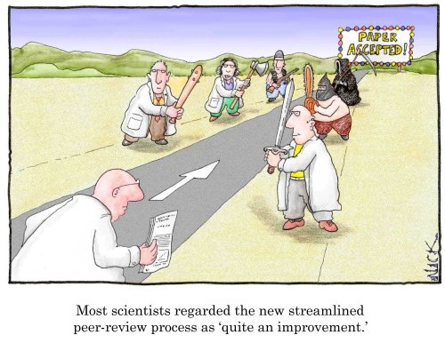

• How does it work?

• Who does the reviews?

• What do you need to do?

How Proposals Are Reviewed

• Most federal agencies use the “peer review” process – experts from backgrounds similar to the applicant evaluate proposals based on a set criteria

• The sponsor’s own personnel, and judgment may be made based on personal interviews or knowledge of the applicant’s strengths. Certain foundation grants may be reviewed in this manner

• At times the review process may not be used at all.
Procurements issued to a specific entity may be used based on prior work done by the applicant or by the need for a quick turn-
around. Usually the sponsor is required to have rationale for their decision to use this type of “sole source” awarding.

General Comments

• You are writing for the reviewers

• Page limits and deadlines are established

• Follow the guidelines

• Get to know the program officer

• Try to obtain the criteria guidelines reviewers will be using

The Goal is in Sight

– Write with a positive attitude

– Have specific aims and objectives

– Leadership + the Plan = $
investment
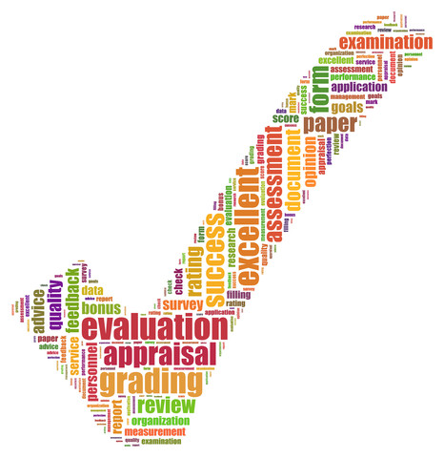

$$ Reward

 Apply to multiple funding sources

 Seek reviewer’s comments to help you with other submissions

Be Persistent!

▪ No one is 100% successful

▪ Request a debriefing with the funder to find out how you can improve chances for next time

▪ Revise and resubmit proposal

Mary Anne Walker mawalker@egr.msu.edu

