**The Grants Process:**

**An Introduction to Proposal**

**Development**

**Mary Anne Walker**

**College of Engineering**

**Fall 2016**



Resources

□  Grant: Resources to support your project idea

□  Cooperative Agreement: Grant with substantial involvement from the funder

□  Contract: Terms and conditions established for goods and services to be delivered on a schedule

**Project Resources**

□  Work with funding agency on defining priorities

□  Maintain a dialogue with program officers

**Industry/Corporate Support**

□  New market interests

□  Link to applied R&D interests

**Locating Funding for Projects**

**US Government: Grants.gov**

**Community of Science** [**http://fundingopps.cos.com/**](http://fundingopps.cos.com/) **Sci Val:**

**http://**

[**www.funding.scival.com.proxy2.cl.msu.edu/home**](http://www.funding.scival.com.proxy2.cl.msu.edu/home)

**The Foundation Center fdncenter.org/funders/ fconline.foundationcenter.org/**

**The Grantsmanship Center tgci.com**

**Foundations**

  Review trends in resource allocation, past grantees

  Align yourselves with those institutions that have a common goal match to your signature programs

  Research web pages for updated information

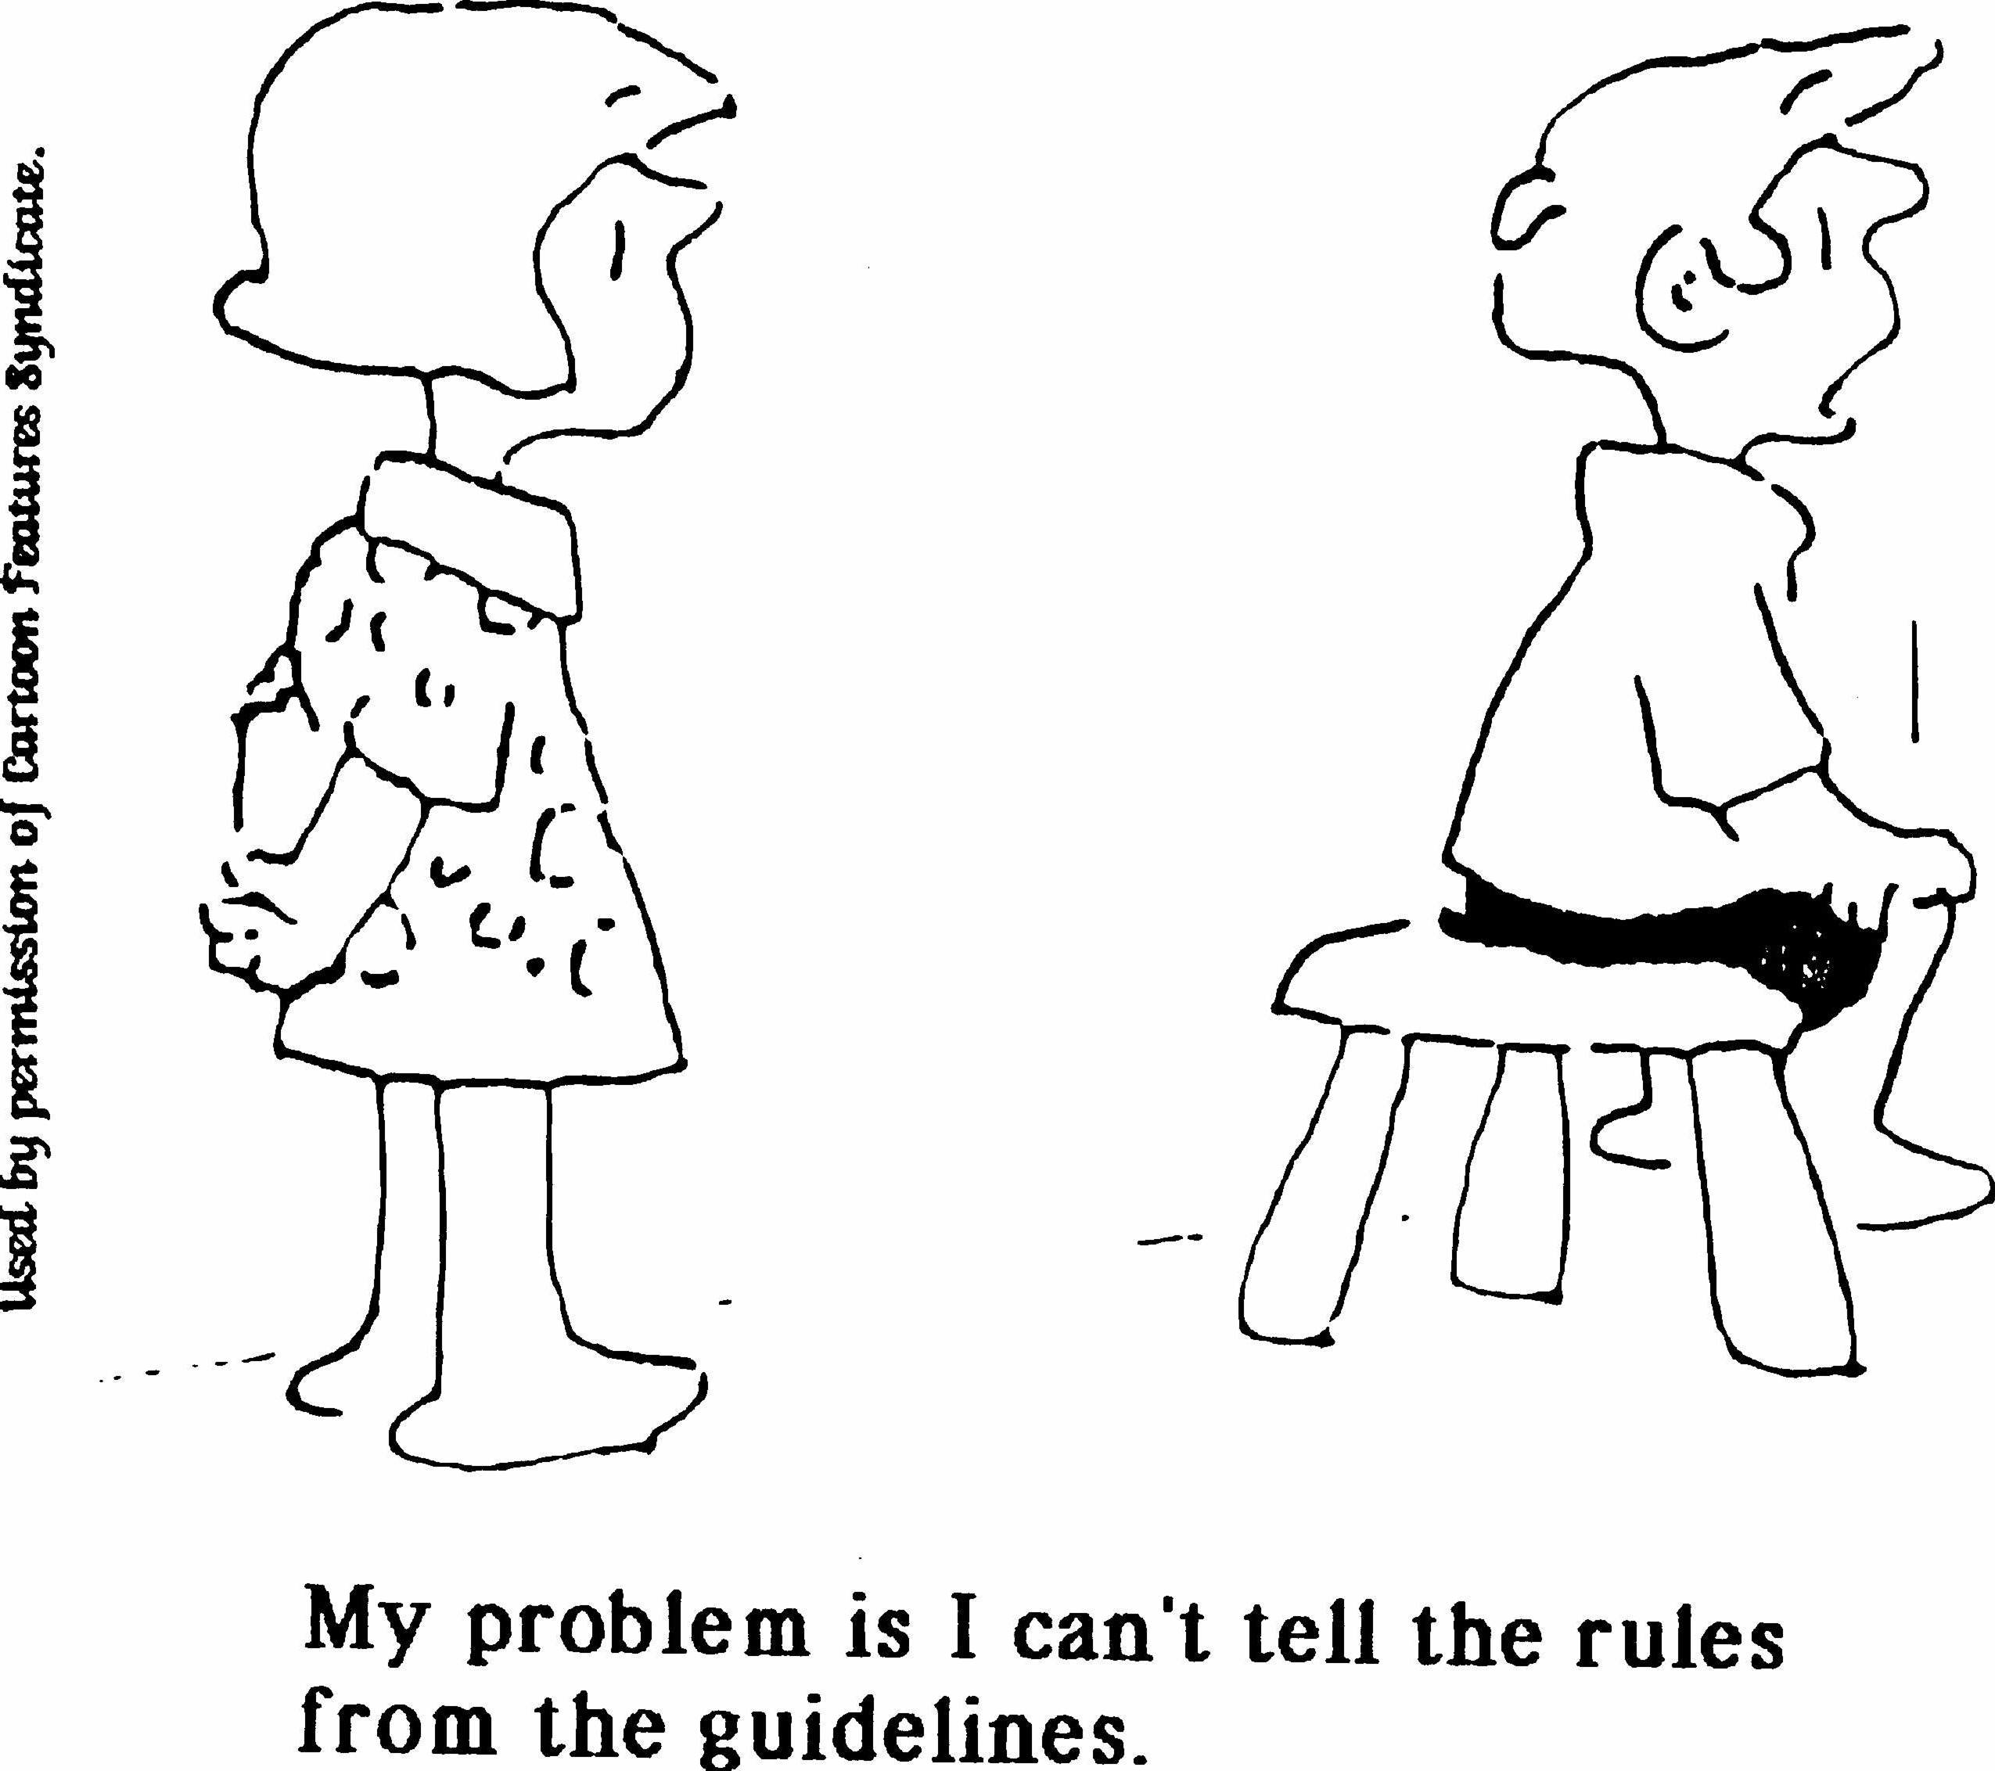

□  **The best way to determine if the program fits your needs is to read the program description and the guidelines**

□  **Contact the Program Officer, create a dialogue**

**Reading the Instructions**

□  **Model Guidelines**

Samples

□  **Forms**

□  **Signatures**

□  **Deadlines**

□  **Format**

□  **Specific requirements**

**Establish a Calendar**

**Getting Started:**

□  **Read and understand the guidelines**

□  **Review past awardees**

□  **Develop a plan**

□  **Identify supporting data needed and key graphic representations**

□  **Establish a timeline for completion of the proposal**

□  **Identify the primary writer and the role of the other collaborators**

□  **Contact the granting agency for information**

**The 90% Rule of Grantwriting**

□  **Understanding the guidelines/requirements**

□  **Developing a sound**

**project concept, including data**

□  **Identifying and correcting the gaps in required information**

□  **Expanding the concept to match the guidelines**

□  **Identifying costs**

______________________________________________________________________________________________________

□  **Writing/Submitting the proposal**

90%

10%

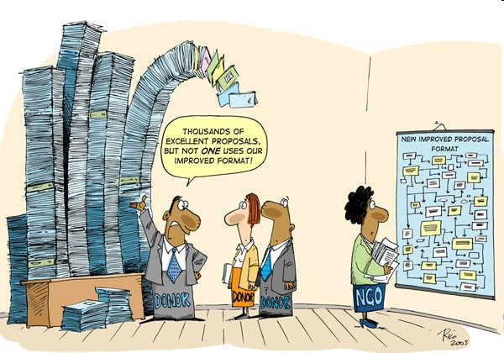**A pre-proposal by any other name….**

□  **Concept Paper**

□  **Letter of Interest/ Inquiry**

□  **White Paper**

□  **Preliminary Proposal**

**Starting with a Basic Concept Note**

□  **Brainstorm to develop a framework for the final proposal**

□  **Answer questions relating to the project, can you articulate the plan start to finish?**

□  **Identify who will develop each section, what other information is needed, are partners required to fill in the gaps?**

Developing a Project Proposal

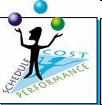**Strategic Visioning**

**Outline Project Description**

  **Who?**

  **What?**

  **Where?**

  **How Long?**

  **Why?**

**The Function of a Proposal**

**The Function of a Proposal**

  **Presents a compelling argument for funding**

  **Represents the organization’s credibility and capacity**

  **Describes the project in persuasive terms**

  **Provides mechanism for evaluation**

  **Tests the ability of the individual to articulate/ conceptualize: If you can state it well, you probably can deliver the project**

**The Essential Components of a Proposal**

□  **Introduction**

□  **Statement of Need/Rationale**

□  **Goals/Objectives**



□  **Organizational Support**

□  **Personnel**

□  **Expected Outcomes**

□  **Evaluation**

□  **Budget and Budget Narrative**

**Description of the Approach to Solve**

**the Problem**

□  **Identifies then modifies, improves, expands, previous efforts; may suggest a new approach**

□  **Discusses specific actions and implementation**

□  **Justifies these in terms of the outcomes to be achieved**

□  **Provides information as to how the process and outcome will be measured**

**Links Between Actions to be Taken**

**and Statement of Problem**

**The problem you are addressing is always the essential element**

  **Each action should link the proposed solution to the problem**

  **Whenever possible, each action should also tie directly to how you will measure your success (Note: sometimes identifying the completion date of an activity can be evidence of success)**

  **Budgets evolve from the actions required**



Are others doing similar

work?

How is your project unique?

**Who Will Perform the Work?**

□  **Identify the persons/organization who will perform the proposed work**

□  **Identify collaborators**

□  **State their expertise, roles on the project, and capacity to do the work**

□  **Network early with potential collaborators; you may need documentation from them that they agree to help in the project’s activities**

□  **Develop capability/qualification statements**

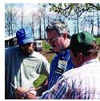

**When to Partner**

□  **When the sponsor requires collaboration**

□  **When elements of the work are being done in separate locations**

□  **When facilities or expertise are not adequate to do all the work**

□  **When an external evaluation component is needed**

□  **When specific expertise is needed**

□  **When the project design mandates comparisons**

□  **When costs could be leveraged by having organizations with common goals working together**

**Partnering Pitfalls**

Be clear about

whom is responsible for what and how resources are to be allocated

  Timeliness

  Deliverables

  Indirect Cost

Return

**Summary Implementation Plan**

□  Develop outline in accordance with a timeline

□  Achieve what results by when?

□  Use charts to relate multiple pieces of information

**Proposed Management Plan**

□  Establish a management structure for the project

□  Create a management entity comprised of those with a vested interest in the outcome of the project: Board of Advisors

Make It Easy for a Funding Agency

to Choose You

□  Keep it simple

□  Plain language, fine to use technical contextbut no jargon

□  Less is more

□  Know what others are doing so you can initiate or complement a program

□  Transparency in budgeting

□  Engage an external reviewer who is unfamiliar with the subject matter

**Establishing Contact with the**

**Funding Agent**



1)  It promotes your institution

2)  It tests the possible compatibility between the potential funder and your institution

3)  It permits you to gather additional information about the funder and possible reaction to your proposal *before* you submit

Bringing the Elements Together:

How to Demonstrate Success



Identify methods to solve the problem in terms of previous approaches and how this model is appropriate

Solution

Proposed

Approach

Specific

Problem

State the anticipated solution and how you will know when it is achieved

Use data, figures, substantiated documentation to further clarify the specific problem

Need

Use data, figures, substantiated documentation to state the need

**Monitoring and Evaluation:**

**Demonstrates impact and measures progress**

□  **Are you meeting targets?**

  **Who, How and When?**

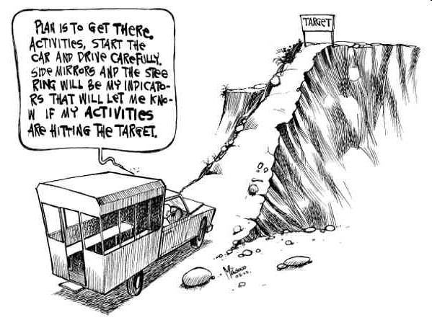□  **Two types**

  **Fiscal**

  **Programmatic**

□  **Accountability**

  **External Evaluation**

  **Self-Correction Opportunity**

**Impact and Outcome**

□  **Provides the sponsor with evidence that the project was completed**

□  **Provides documentation of impact**

□  **Identifies areas for future improvement**

□  **Identifies “dead ends” – can be helpful in identifying what doesn’t work**

□  **Describes how the outcome and useful information can be shared with others**

NOTE: Sponsors are accountable for the investment of their funds; a well-defined evaluation or measurement of outcome is important

**Steps to Sustainability**

□  **Seek additional funding**

□  **Integrate training on partnership activities to build capacity**

□  **Ensure community involvement**

□  **Train those invested in project to continue efforts once the project partners have fulfilled commitments**

**Budgeting and Accounting**

□  **Be realistic in terms of cost:**

□  **Travel**

□  **Accommodations**

□  **Local Transportation**

□  **Supplies**

□  **Communications**

□  **Equipment (materials, etc.)**

□  **Publications**

□  **Evaluation Services**

□  **Miscellaneous**

**Budgeting Goals**

□  Accurately Estimate Needs for Funding

Project

□  Properly Estimate Cost-Sharing to Meet the

Requirements

□  Use format required by the funding agent

**The Budget Line – By - Line**

□  Salaries

□  Always include as the first line-item

□  Note % of effort to complete a task

□  Amounts paid on a grant for salaries are NOT

supplemental pay

□  Include inflation factor (4-7%)

□  Fringe Benefits

□  Use rate increase for future periods

**The Budget Line – By - Line**

□  All Other Direct Costs

□  Subcontracts for collaborative projects with other partners

 Indirect Costs

**Common Budget Mistakes**

  Include your time as a level of % effort

  Make certain the budget adds up correctly

  Put commas in numbers, easier to read

  Use a column format, numbers align on right

  Label all budget categories, leave nothing blank

  Be realistic about the time you can commit, if you have 3 projects at 50% time and they are all funded, you’re in trouble!

**Packaging the Proposal**

□  Spell check content before giving to an external reviewer for comment

□  Cover letter

□  Review your checklist

**The Review Process, or Writing**

**Backward for Progress**

□  **Identify the reviewer’s criteria**

□  **Highlight and define specific elements as priorities when appropriate**



□  **Be redundant if the point is essential….**



□  **Remember, this is a**

**“sales tool”**

Scoring

Criteria

How are Proposals Reviewed

□  Proposals are reviewed in a variety of different ways: most federal agencies use the ***“peer review”*** process – experts from backgrounds similar to the applicants evaluate proposals based on a set criteria

□  Proposals may also be reviewed by the sponsor’s own personnel, and judgment may be made based on ***personal interviews or knowledge of the applicant’s strengths.*** Certain foundation and corporate grants may be reviewed in this manner

□  At times the review process may not be used at all. ***Procurements*** issued to a specific entity may be used based on prior work done by the applicant or by the need for a quick turn-around. Usually the sponsor is required to have back-up for their decision to use this type of “sole source” awarding. Some sponsors issue a cooperative agreement to create a long-term relationship with an organization to facilitate procurement for specific tasks

**The Review Process**



□  **How does it work?**

□  **Who does the reviews?**

□  **What do you need to do?**

**General Comments**

□  **You are writing for the reviewers**

□  **Page limits and deadlines are established**

□  **Follow the guidelines even if they don’t**

**“flow” as you would like**

□  **Get to know the program officer**

□  **Try to obtain the criteria guidelines reviewers will be using**

**Your Ideas**

□  **Must be interesting and understandable to a broadly-trained audience**

□  **Clear communication - don’t get lost in the details**

□  **Include one summary diagram or model early to highlight the problem and specific aims**

**The Goal is in Sight**

  **Write with a positive attitude**

  **Have specific aims and objectives**

  **Leadership + the Plan = $ investment**



**The Review**

□  **Clear communication**

□  **Concisely worded**

□  **Easy and interesting to read**

□  **Communicate the importance of your work to the community**

**Final Guidance**

□  Always have an external reader that doesn’t know about your project to give you honest feedback

□  It often takes a TEAM

□  Seek advice from colleagues, mentors

□  Allow enough time for final review

**After Submission of Proposal**

Keep looking for future grant opportunities



**When Failure is Not Failure…**

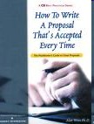□  **Sometimes sponsors want to get to know you…your initial proposal may be a “gate opener” for discussion**

□  **Some sponsors have a formal structure for resubmission; they expect it**

□  **Peer Review and Commentary is a significant tool for eventual funding**

**Be Persistent!**

□  No person or organization is funded every time they submit

□  Request a debriefing with the funder to find out how you can improve chances for next time

□  Revise and resubmit proposal